University of Massachusetts Dartmouth
Department of Computer and Information Science

Data Mining Approaches for Detection of Suspicious Bidders
in Online Auctions

A Thesis in
Computer Science
by
Benjamin J. Ford

Submitted in Partial Fulfillment of the
Requirements for the Degree of
Master of Science

September 2010

I grant the University of Massachusetts Dartmouth the non-exclusive right to use
the work for the purpose of making single copies of the work available to the public
on a not-for-profit basis if the University's circulating copy is lost or destroyed.

___________________________________
Benjamin J. Ford

Date _______________________________
We approve the thesis of Benjamin J. Ford
Date of Signature
_________________________________________ ____________________
Haiping Xu
Associate Professor, Department of Computer and Information Science
Thesis Advisor

_________________________________________ ____________________
Iren Valova
Professor, Department of Computer and Information Science
Thesis Committee

_________________________________________ ____________________
Chi Keung Lee
Assistant Professor, Department of Computer and Information Science
Thesis Committee

_________________________________________ ____________________
Jan Bergandy
Professor
Graduate Program Director, Department of Computer and Information Science
Acting Chairperson, Department of Computer and Information Science

_________________________________________ ____________________
Robert E. Peck
Dean, College of Engineering

_________________________________________ ____________________
Alex J. Fowler
Associate Provost for Graduate Studies

ABSTRACT

Data Mining Approaches for Detection of Suspicious Bidders
in Online Auctions
By Benjamin J. Ford

Auction fraud has become a more important issue with the increase in popularity of online auction houses such as eBay. Shill bidding, a type of auction fraud, refers to the practice of users placing bids on an auction with the sole intent of raising the final selling price and not with the intent of winning the auction. However, the increase in popularity makes it infeasible to manually process and investigate all auctions and bidders for shill bidders. As a result, automated mechanisms such as data mining techniques are becoming more necessary to process this increasing workload. In this thesis, we first examine and quantify observable features related to suspicious bidding behavior. Then we utilize a hierarchical clustering algorithm to group bidders with similar behavior, and manually label each group as normal or suspicious to create a training dataset. Using the training dataset, we generate a decision tree to efficiently classify new bidders as normal or suspicious ones. In order to detect suspicious bidders in real-time, we further present a real-time self-adaptive classifier (RT-SAC) framework using an incremental neural network approach. The neural network is initialized with labeled historical auction data, and can be trained incrementally to gradually adapt to new data points. As such, the classifier is able to keep pace with changing bidding trends without a significant loss in accuracy and time performance. We use a case study to demonstrate how to tune parameters for RT-SAC and how our approach can be used to effectively detect suspicious bidders in real-time.
TABLE OF CONTENTS
1. Introduction 1
2. Related Work 6
3. Background Knowledge 10
3.1 Hierarchical Clustering 10
3.2 Decision Trees 13
3.3 Backpropagating Neural Network 16
3.3.1 Resilient Backpropagation 20
4. Feature Selection and Clustering 25
4.1 Attribute Discussion 28
4.1.1 User attributes 30
4.1.2 Stage attributes 31
4.1.3 Auction attributes 37
4.2 Grouping Bidding Behavior using Hierarchical Clustering 39
5. Identifying Suspicious Bidders Using Decision Tree 41
5.1 Experimental Results and Analysis 41
6. A Framework for Real-Time Self-Adaptive Classifier 47
6.1 RT-SAC’s Neural Network Output Decision Function 50
6.2 Design of Selection and Replacement Rules for Reasoning 51
6.2.1 Outlier Detection 52
6.2.2 Creation of Training and Validation Datasets 54
6.2.3 Data Pool Replacement Policies 56
6.3 Design of Rules for Real-Time Training 58
7. RT-SAC Case Study 62
7.1 Data Collection and Preprocessing 62
7.2 Implementation of Self-Adaptive Neural Network 66
7.3 RT-SAC Experiments Results and Analysis 69
7.3.1 Simulations of Real-Time Training and Classification 69
7.3.2 Experiments for Parameter Tuning 72
7.3.3 Experiments to Demonstrate Classifier Adaptation 79
8. Conclusions and Future Work 86
9. References 87

LIST OF FIGURES
Figure 3.1 Cluster Similarity Equation 11
Figure 3.2 Cluster Centroid Equation 11
Figure 3.3 Hierarchical Clustering Algorithm 12
Figure 3.4 Shannon’s Entropy Equation 14
Figure 3.5 Information Gain Equation 14
Figure 3.6 Information Gain Ratio Equation 15
Figure 3.7 Decision Tree Generation Algorithm 15
Figure 3.8 Sigmoid Activation Function 19
Figure 3.9 Example Neural Network Layout 20
Figure 3.10 Standard backpropagation algorithm 23
Figure 3.11 Resilient backpropagation algorithm 25
Figure 4.1 A Framework for Identifying Suspicious Bidders in Real-Time 28
Figure 4.2 Bidder Attribute Hierarchy 30
Figure 4.3 Average Competitive Interval Equation 33
Figure 4.4 Average Interval Difference Equation 34
Figure 4.5 Average Time between User Bids Equation 35
Figure 4.6 Average Outbid Time Equation 37
Figure 5.1 Decision Tree for Fold 1 46
Figure 6.1 Architectural Design of Real-Time Self-Adaptive Classifier 49
Figure 6.2 New Auction Data Processing Algorithm 50
Figure 6.3 Graphical Representation of a Window 50
Figure 6.4 Outlier Detection Rule 54
Figure 6.5 Set Creation Facts 56
Figure 6.6 Data Pool Replacement Policy Rule 57
Figure 6.7 Stopping Conditions Rule 61
Figure 7.1 Combined Error Rate Equation 72
Figure 7.2 Experimental Results for Tuning of Window Size 74
Figure 7.3 Experimental Results for Tuning of Outlier Threshold 76
Figure 7.4 Experimental Results for Tuning of Hidden Neurons 78
Figure 7.5 Simulation Results for Recent Data Points Collected without a Time Gap 79
Figure 7.6 Time results for recent data points collected without a time gap 81
Figure 7.7 Simulation Results for Recent Data Points Collected with a Time Gap 83
Figure 7.8 Time results for recent data points collected with a time gap 85

LIST OF TABLES
Table 5.1 Training Data Clusters for Fold 1 44
Table 5.2 3-Fold Cluster Summary 45
Table 5.3 Decision Tree Results 46
Table 7.1 Cluster Labeling for Dataset 1 65
Table 7.2 Cluster Labeling for Dataset 2 66

ACKNOWLEDGEMENTS
I would like to extend my sincerest gratitude to Dr. Haiping Xu, Dr. Iren Valova, and Dr. Kenneth Lee. Dr. Xu went far beyond the schedule typically expected of a thesis advisor. It was not uncommon to communicate via email through the weekend or to hold a weekly meeting that extended for anywhere between one or even two and a half hours. In addition, his patience and unerring persistence for quality ensured that I would not settle for a project or thesis that was any less than excellent, even when I was at my most discouraged and ready to give up. As a result of working with him for two years, we’ve also completed two conference papers and a journal publication. I would like to thank him for all of his patience, efforts, and hard work in regards to these publications.

Dr. Valova’s guidance regarding neural networks, quite possibly, saved me months of additional effort and frustration in trying to understand the intricacies of neural networks and how various environmental parameters significantly impacted their performance. Dr. Kenneth Lee agreed to be on my thesis committee on very short notice and I would like to thank him for his time in taking this additional responsibility. Also, I would like to thank the National Science Foundation for providing the grants, CNS-0715648 and CNS-0715657, which funded the research behind this thesis.

Introduction

Online auction houses, such as eBay, have recently experienced a dramatic increase in their popularity. From December 1, 2009 to July 1, 2010, the number of listings hosted by eBay has increased from approximately 37.2 million to a staggering 110 million listings [1]. However, this significant increase in popularity also means more chances for online auction fraud to be conducted. Furthermore, some online auction houses such as eBay have instituted a policy where bidders’ identities are obfuscated from other users, which makes it even more difficult for users to carry out their own investigation on a seller. This policy, in addition to the already anonymous nature of the Internet, makes online auction fraud easy to conduct. For example, sellers and colluding users may place fake bids for the sole purpose of increasing the final price of an auction [2], or boost each other’s feedback ratings to trick users into thinking that the seller is trustworthy [3, 4]. Since it is clear that the amount of auction data to be processed has increased significantly, automated mechanisms such as data mining techniques have become more important than ever.

Shill bidding is a type of auction fraud, which refers to the practice of sellers using a faked bidder account or asking another bidder to place bids on their auctions for the purpose of raising the final price. This fraudulent activity causes legitimate bidders to pay significantly more for winning an auction. In addition, [2] discusses the potential of market failure as a direct result of excessive shill bidding. If buyers do not trust sellers to participate fairly (i.e. no shill bids in their auctions), they will place bids that are far lower than usual, in order to avoid being victimized by shill bidding. The seller will, in turn, place shill bids that are for a lower amount, resulting in a lower final auction price. This cycle may continue until participation and the market fails. In a faceless environment, such as the Internet, a seller can easily create a secondary account or participate in organized groups of shill bidding [2]. Unlike blatantly obvious forms of auction fraud, such as non-delivery fraud, shill bidding typically goes undetected by those victimized, especially by those who do not know how to recognize the subtle signs of shill bidding. Existing approaches, such as a D-S theory based verifier, are capable of verifying shill bidders using collected evidence, but they are not efficient for analyzing large datasets [5]. Therefore, it is important to define automated mechanisms that can efficiently detect suspicious bidders in order to narrow down the number of bidders to be verified for shill bidding. By reducing the workload for verifiers, we can efficiently process more auctions, detect shilling behavior, and expose fraudulent sellers and colluding users.

In this paper, we present a decision tree which can efficiently detect suspicious bidding behavior. If a new bidder is classified as suspicious or highly suspicious, we can use existing verification techniques, such as Dempster-Shafer (D-S) theory [5], to verify shill bidders. Note that existing approaches, such as D-S theory, are not efficient for analyzing large datasets. By efficiently identifying suspicious bidders in online auctions, our approach strongly complements existing techniques for shill detection, which suffer from time inefficiency.

In order to handle the vastly increasing workload of auction data, we introduce a real-time self-adaptive classifier (RT-SAC), which can be used to efficiently identify suspicious bidders in recently closed online auctions. Because changes in bidding trends are inevitable, we no longer use decision trees for classification, as they cannot quickly or gradually adapt to classify changing data. Instead, RT-SAC utilizes a feed-forward backpropagating neural network that can be trained in real-time. Once the network receives a set of bidders and decides which ones are suspicious, it sends the suspicious bidders to a verifier for further investigation. As time progresses and the popularity of particular items changes, bidding trends are sure to change. If the classifier is not constantly reevaluating itself, it is likely that classifier will become outdated and unable to correctly classify new data. Therefore, we use the classification results and the results from the verifier to adapt the network to recent bidding data. By doing so, our classifier can accurately follow changing market trends without a significant decrease in classification accuracy.

It is important to note that this adaptation process is fast enough to be done in real-time. Our approach’s main goal is to increase the efficiency of an accurate, but inefficient, verifier. If the adaptation process takes too long to complete, our approach will be unable to keep up with the increasing quota of online auctions to be analyzed. Therefore, we incrementally train the network on new data instead of reinitializing it. Reinitializing a network takes significantly more computation effort and time than incremental training. Thus, the incremental training approach is well suited to our time constraints.

Before we can utilize any classifier for our approach, we need to create usable training data to teach the classifier. There are obstacles that arise in regards to creating a training dataset. A lack of previously analyzed datasets and describing suspicious bidding behavior primarily based on auction bidding histories pose significant difficulties for our approach. Many areas of research, such as cancer research, benefit from the availability of a vast selection of well-studied scientific data. Because there are no such datasets for our research, we must collect, analyze, and label a new dataset. This process leads into our next obstacle: accurately describing suspicious bidder behavior. In order to utilize automated techniques, the bidders contained in any collected bidding data must be described in quantifiable terms. We present a series of attributes that can be used to accurately describe shilling behavior and its various symptoms. Once the bidding data has been characterized using these attributes, we use a hierarchical clustering algorithm to create groupings for the bidders. Once the groups have been examined and each bidder has been identified as normal or suspicious, the results can be used to create a decision tree or neural network.

The rest of the paper is organized as follows. Section 2 summarizes the related work to our approach. Section 3 discusses background knowledge that is useful for fully understanding our approach. Section 4 presents the overall framework and dataset creation process, including attribute definition and bidder labeling. We discuss our decision tree creation approach and experiment results in section 5. In section 6, we introduce the RT-SAC framework and discuss all of its various components. To demonstrate the effectiveness of our framework, we present a case study in section 7. In section 8, we summarize our conclusions and discuss future work.

Related Work

Previous work using data mining techniques to categorize groups of bidders based on their bidding behavior is summarized as follows. Bapna, et al. utilized k-means clustering to generate five distinct groups of bidding behaviors for Yankee Auctions [6]. They observed that users can improve the execution of their bidding strategies over time by adopting agent bidding to lower their bidding costs. Shah, et al. analyzed collected auction data from eBay to generate four distinct groups of bidding behavior [7]. The analysis revealed that there are certain bidding behaviors that appear frequently in online auctions. Hou and Rego used hierarchical clustering to generate four distinct groups of bidding behaviors for standard eBay auctions, namely goal-driven bidders, experiential bidders, playful bidders, and opportunistic bidders [8]. They concluded that online bidders are a heterogeneous group rather than a homogenous one. Although the above approaches look closely related to the first portion of our proposed approach, they focus on creating clusters based on the assumption that bidders are honest ones with no malicious intentions. Thus, the clusters generated using these approaches reflect that bidders are all normal, even though there is significant evidence for shilling behavior. Shah, et al. also attempted to identify shill bidders and associate them with a particular bidding behavior [7]. However, their results indicated that none of their identified bidding activities could be directly linked to shilling behavior. Unlike these approaches, our approach creates groups of bidders based on behavior that can describe suspicious activities.

There has been limited work towards detecting shilling behavior in a single auction. Bates, et al. utilize a real-time model checking approach to calculate a shill score for bidders in a single auction [9]. The approach examines a bidder’s behavior throughout an auction and monitors for behaviors directly related to shill bidding. If any of these behaviors are detected, their shilling score will increase. A bidder’s shill score can only decrease by avoiding shilling behavior throughout the rest of the auction. Although this approach can efficiently detect shilling behavior in a single auction, it is inflexible to changes in bidding trends. If bidding trends change such that shilling behaviors only accumulate small additions to the shilling score, this model-checking approach will not automatically adapt to these changes. In contrast, our neural network continuously adapts to new bidding data. By doing so, our approach can account for any changes in bidding trends without a significant loss in accuracy or increase in classification or training time.

Fei, et al. propose a verification approach that utilizes Dempster-Shafer Theory. By analyzing every bidder’s activity in all previously recorded auctions, the verifier can utilize more than enough evidence to accuse a shill suspect. Determining a sufficient amount of evidence is done using Dempster-Shafer Theory, which allows the verifier to reason under uncertainty. If the investigation exceeds a determined belief threshold, the bidder is marked as a shill bidder [5]. Goel, et al. utilize multi-state Bayesian networks to verify detected shill bidders. Similar to Dempster-Shafer theory, Bayesian networks are capable of reasoning under uncertainty and calculate varying degrees of probability that a bidder is a shill bidder [10]. These techniques, however, suffer from being too thorough in their investigation of a bidder. It is infeasible to thoroughly process every bidder in every auction, especially when the current trend of listings is on the rise. By quickly analyzing a single auction to find suspicious bidders, our approach can significantly reduce the workload for these verifiers. In addition, our case study demonstrates that most bidders do not behave suspiciously; a verifier that processes every bidder will find that most of its execution time is spent thoroughly investigating normal bidders. By combining our single-auction investigation approach with a precise verifier, we can efficiently detect occurrences of shill bidding.

The use of neural networks to aid in fraud detection has been successful in other related work. Fei, et al. successfully used the LAMSTAR neural network to predict the end price of various auctions. They propose that auctions with a higher than average end price are more likely to contain shills. As a result, they utilize the network to predict the end price of the auction and then use a D-S theory verifier to investigate suspicious appearing auctions [11]. Wang and Chiu utilize a neural network and statistical models to identify instances of artificially inflated feedback scores. They first examine the relationships between buyers and sellers, the end prices of related auctions, and other related data to create a score called an SNA indicator. By providing SNA indicators to a neural network or statistical model, they successfully identify instances of artificially boosted feedback [12]. Both approaches, however, still need to process every bidder in every completed auction. We propose that these approaches, in addition to the approaches described in other related work, could benefit greatly from the increased efficiency provided by our framework.

[13, 14] utilize neural networks in situations that require a great deal of time efficiency. [13] develops a model that combines a fuzzy clustering approach and a standard neural network approach to predict urban traffic flow. Instead of training the neural network on a single large batch of data, they incrementally train the network as the system receives data. They demonstrate that this process allows the network to quickly adapt to changing traffic trends. [14] utilizes a neural network to control the speed of a complex permanent-magnet motor. Before the system executes, they initially train the neural network with a large batch of data. Afterwards, they use an incremental training approach to adapt the neural network to changing environmental conditions and demands without taking the motor offline. As demonstrated in these approaches, an incremental training approach can be useful for quickly adapting to changing trends. However, this approach has not yet been applied to auction fraud detection. As we demonstrate in this paper, incremental training is a viable approach when applied to the detection of suspicious bidding behavior.

Background Knowledge

In this section, we introduce some fundamental concepts that are necessary for understanding our approach.

3.1 Hierarchical Clustering

We utilize hierarchical clustering techniques to cluster collected data points. Hierarchical clustering is known to have significant advantages over flat clustering techniques such as k-means [15]. Flat clustering algorithms require the number of clusters to be defined prior to execution, which significantly affects the clustering results. However, determining the proper number of clusters is not a trivial and arbitrary task. Flat clustering algorithms may also lead to nondeterministic results. For example, given an input, the algorithm may generate numerous different sets of results, but it is impossible to know whether the set of results is complete or the optimal result has been generated. Thus, justifying a set of results generated using a flat algorithm is very difficult. Although hierarchical clustering algorithms are at least quadratic in time complexity, this does not affect our decision since the cluster analysis is performed offline and not constrained by time [15].

An important aspect of clustering is the similarity measure, which determines when elements shall be added into a cluster. At a given point in a clustering process, two clusters deemed to be the most similar are the ones to be combined into a single cluster. For our approach, we use centroid clustering as our similarity measure. Centroid clustering is known to be not as heavily affected by outliers as single-link or complete-link similarity measures [15]. Since we are certain to have outliers to be identified from our collected dataset, we require the similarity measure to possess this quality.

The similarity between two clusters is determined by the similarity between the centers (centroids) of the two clusters, as shown in Figure 3.1. The centroid of a cluster is equivalent to the vector average of the cluster’s members, as shown in Figure 3.2.
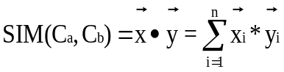
Figure 3.1 Cluster Similarity Equation

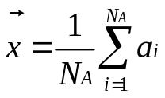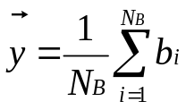
Figure 3.2 Cluster Centroid Equation

In addition to the similarity measure, it is also important to specify a minimum similarity cutoff. The cutoff value determines when the clustering process should terminate. If two clusters’ similarity does not exceed this cutoff value, they are not combined. Note that if a cutoff point is not specified, the clustering algorithm eventually outputs a single cluster containing all of the elements. The cluster generation algorithm is defined recursively in Figure 3.3.

generateClusters(WeightedResults results, ClusterSet clusters, double minimumSimilarity)
If clusters == null
For each element e of results
Store e in a new cluster c
Store c in clusters
Return generateClusters(results,clusters,minimumSimilarity)
Else if clusters has only one element
Return clusters
Else
For each cluster c in clusters
For each cluster d in clusters
If c and d are not the same cluster and have not been previously compared
Calculate the similarity between c and d
If similarity > maximumSimilarity && similarity > minimumSimilarity
maximumSimilarity = similarity
cluster1 = c
cluster2 = d
If two clusters have been chosen to merge
Merge cluster1 and cluster2 into a new cluster e.
Remove cluster1 and cluster2 from clusters
Store e into clusters
Return generateClusters(results,clusters,minimumSimilarity)
Else
Return clusters

Figure 3.3 Hierarchical Clustering Algorithm

3.2 Decision Trees

The decision tree generation requires a set of input attributes and an output attribute that determines a bidder’s appropriate classification. When creating a decision tree, the dataset used as a training set determines the structure of the tree. Each node of the tree, including the root, corresponds to a set of examples from the training set. The leaf nodes in this tree contain a set of examples such that they all have the same value for the output attribute. A splitting function is used to determine which input attribute should be assigned to a non-leaf node. The chosen attribute determines the number and contents of the node’s children. For example, if the input attribute NB (early) has five possible values and is chosen for the root node, the root node can have up to five children, each corresponding to a value for NB (early). Each of these children contains a subset of the training set such that all the children’s elements correspond to the value chosen for its parent’s corresponding attribute.

We utilize the information gain ratio as our splitting function. Because most attributes are continuous values, the number of discrete values for most attributes can be quite large. Data binning is used to compensate for this difficulty. For attributes that contain non-integer values, such as ETFB, four bins are created. The four bins correspond to values equal to zero, less than or equal to M/2, greater than M/2 but less than M, and values equal to M, where M is the maximum value. This binning procedure is necessary because the information gain function is known to favor attributes with a large number of values for the attribute. For example, an attribute with thousands of values could be used to classify the entire training set, but if this attribute is a unique identifier, such as social security number, it is obvious that any new examples will not be properly mapped. This issue is referred to as overfitting. The information gain ratio function overcomes this favoritism. The equations to calculate the Shannon’s entropy (E) as a criterion for selecting the most significant attribute, the information gain (GAIN) for choosing an attribute to split upon, and the gain ratio for choosing an attribute to split upon are given in Figure 3.4, Figure 3.5, and Figure 3.6, respectively. In Figure 3.4, X can be an input or output attribute for the current training set, and P(v_{i}) refers to the probability that the attribute has the value of i, which represents a class number. In Figure 3.5, X refers to an input attribute that has been chosen for a split, Y refers to an output attribute, and E(Y | X = v_{i}) refers to the information contained in the output attribute for the training set that results from choosing X for the split. In Figure 3.6, the gain ratio is calculated as a quotient of information gain over Shannon’s entropy.
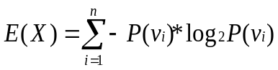
Figure 3.4 Shannon’s Entropy Equation

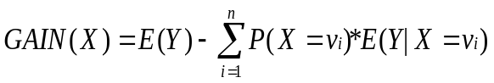
Figure 3.5 Information Gain Equation

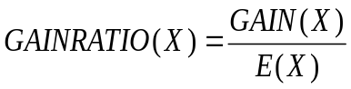
Figure 3.6 Information Gain Ratio Equation

Based on the information gain ratio, a decision tree can be generated using the recursive decision tree generation algorithm, adapted from [16], shown in Figure 3.7.
1. generateDT(ClusterSet clusters, DecisionTree tree, int maxDepth, float minGain)
2. if no nodes in tree can be split || maxDepth is reached
3. return tree
4. else // split a node
5. choose a node n that is not perfectly partitioned
6. curSet = n.trainingSet
7. remainingAttributes = n.remainingAttributes
8. if there are no more remaining attributes
9. mark n as being perfectly partitioned
10. return generateDT(clusters,tree,maxDepth,minGain)
11. else
12. initialize maxRatio to 0, and splitNode to false
13. for each attribute x in remainingAttributes
14. calculate x’s gain ratio r based on curSet
15. if r > maxRatio && r >= minGain
16. maxRatio = r; bestAttribute = x
17. set splitNode to true
18. if splitNode == false
19. mark n as being perfectly partitioned
20. return generateDT(clusters,tree,maxDepth,minGain)
21. else // splitNode == true
22. partition curSet into new nodes based on bestAttribute
23. link and add the new nodes into tree
24. return generateDT(clusters,tree,maxDepth,minGain)

Figure 3.7 Decision Tree Generation Algorithm

The decision tree generation algorithm first checks if any nodes can be split without violating the previously described constraints. If so, then it chooses a node that is eligible for splitting. If there are remaining input attributes, the information gain ratio is calculated for each of them. The attribute with the highest ratio is chosen as the attribute for node splitting if the highest ratio is no less than the predefined minimum information gain minGain. In this case, children nodes of the splitting node are created, and each child’s training set contains the elements corresponding to their values for their parent’s attribute. This process continues until no nodes can be split or the maximum depth has been reached.

Once a decision tree has been generated using a training set, a test set is chosen to evaluate the effectiveness of the decision tree. This process begins at the root node and ends at a leaf node. For each test element, its value for the root node’s attribute is retrieved and compared to the various branches from the root node. The next node is obtained by following the branch with a matching value, and the element’s value for that node’s attribute is retrieved. This process repeats in a similar fashion until a leaf node is reached. Once a leaf node is reached, the value of the leaf node is used to classify the test set element as a member belonging to a certain class. When all test set elements have been classified, their classifications are compared to the labels assigned to them in the clustering process described in section 3.1. If a decision tree’s classification matches with its pre-assigned cluster label, the classification is said to be correct.

3.3 Backpropagating Neural Network

One of the major components of RT-SAC is a feed-forward backpropagating neural network that is used to classify participating bidders of a recently completed auction. Basic neural networks, such as perceptrons, are utilized to effectively classify data that are linearly separable. However, due to the changing nature of consumer behavior and the subtleties of shill bidding, it is difficult to justify bidding data as linearly separable. As a result, we looked into classifiers that are capable of classifying linearly inseparable data; feed-forward backpropagating neural networks are known to possess enough complexity to effectively classify linearly inseparable data [17]. In addition, neural networks do not have to be completely reconstructed when new training data is presented to it. Once we train a new neural network on an initial dataset, the classifier can adapt this network to new data points. This incremental approach has the distinct advantage of utilizing a smaller training set, which leads to faster training times, and retaining the ability to classify previously presented data. Although this approach can be prone to overfitting on the current training data, our process overcomes this disadvantage by utilizing the previously described window concept. By using additional data from the data pool, the classifier adaptation process is more gradual and does not negatively impact the convergence rate for new data.

Since the inner representation of a neural network’s decision making process is so complex, neural networks are typically used as a black-box approach to solving a problem. For our purposes, we do not need to understand how the neural network classifies the bidders, only that it is correctly classifying a representative testing set [17].

A neural network works by using a set of nodes, called neurons, to process an input signal and produce an appropriate output signal. For example, if a neural network is simulating the XOR function, the network should output {true} on an input of {false, true}. A neuron in the network can have multiple input and output links to send and receive signals. A neural network processes its input by sending the input signals through these connecting input and output links. If a particular neuron’s input exceeds a threshold, the neuron will “fire” and send a signal through its output links. Otherwise, the neuron will drop the signal. A feed-forward neural network transmits signals in one direction, from the input layer to the output layer.

When using neural networks, we first need to specify the structure, which includes the number of layers, the number of neurons on each layer, and the activation functions between layers. The neural network we adopted in RT-SAC consists of three layers. The first layer, called the input layer, must contain a neuron for every input attribute being used to describe a bidder. The second layer, called the hidden layer, can contain any number of neurons. Typically, an incorrect number of hidden neurons will lead to poor classifier performance. Too few neurons will result in fast but inaccurate training, whereas too many neurons will lead to unnecessarily long processing times. Since there is no general approach to determining the optimal number of neurons in the hidden layer, this number is typically found by experimentation [17]. The last layer, called the output layer, consists of two neurons, one for each possible bidder class assignment.

A layer’s activation function determines the firing rules for its residing neurons. Depending on the activation function, a neuron’s output can change significantly for a particular input. . We define the commonly used sigmoid function as the hidden layer’s and output layer’s activation function. To better illustrate the concept of an activation function, the sigmoid function is displayed in Figure 3.8. For example, if any neuron in the hidden layer receives an input that is greater than 1, that neuron will output a value of 1 on its output links. Since the input layer does not have any input links, it does not use an activation function.
double sigmoid(double sum)
If(sum >=1)
Return 1
Else if(sum <= -1)
Return 0
Else
Return
Figure 3.8 Sigmoid Activation Function
Finally, links connect the layers of neurons together. For every neuron in the input layer, there will be a link to every neuron in the hidden layer, and for every neuron in the hidden layer, there will be a link to every neuron in the output layer. Figure 3.9 demonstrates the layout of a feed-forward neural network.
1
2
.
.
.
n
1
2
m
.
.
.
1
2
Figure 3.9 Example Neural Network Layout

A network’s links contain weights that determine the relative importance of signals being sent. For example, suppose a neuron in the hidden layer has two input links from the input layer. If the first link has a weight of 0 and the second link has a weight of 1, it would mean the first input neuron is completely insignificant and the second neuron is entirely significant in the firing of this hidden layer neuron. A network’s neurons also contain a bias term that determines the relative importance of the particular neuron in the network’s ability to classify data. If a neuron has a high bias, it will fire more often than a node with a low bias.

3.3.1 Resilient Backpropagation

For our approach, we utilize a resilient backpropagation algorithm to train the network. Resilient backpropagation is a supervised learning technique that has shown promising classification accuracy and time performance results compared to other popular training techniques, including generic backpropagation and the SuperSAB algorithm [18]. Supervised learning techniques require that each training example be accompanied by its correct classification. For example, if a suspicious bidder is presented to the network for training, the network must be informed that it is a suspicious bidder so it can learn from any mistakes it made and improve its future classification of similar bidders. Initially, the network’s weights and biases are randomized. The training phase of a neural network focuses on adjusting these weights and biases so that data points in two sets, a training and validation set, are correctly classified. This process usually takes many iterations to complete satisfactorily. The training set is the main set of data used to modify the weights and bias of the network. A validation set is classified after each training iteration to determine the accuracy of the current network. If the network cannot correctly classify a large enough percentage of the validation set, another iteration takes place. Because our approach requires a great deal of time efficiency, we also specify various stopping conditions. A stopping condition that evaluates to true will cause the training process to abort, no matter the quality of the current solution. In addition to improving the time efficiency of the training process, early stopping conditions are commonly used to prevent overfitting of the network. Common stopping conditions include thresholds on validation performance and training performance, a minimum and maximum number of training iterations, and minimal acceptable improvements in validation performance [19, 20, 21]. These stopping conditions are covered in more detail in section 6.2.

As a point of comparison, we present the standard backpropagation algorithm in Figure 3.10. First, the weights and biases are initialized to a random value. In addition, a learning rate parameter must be specified. Similar to the number of hidden neurons, this is usually found by experimentation. When each training item is processed by the algorithm, the current network must classify it. This step is known as a forward pass. The backpropagation phase, also known as a backward pass, first involves calculating an error term at each neuron, starting at the output neurons. Once this error term is calculated, the algorithm calculates how much it needs to change all the weights and biases associated with the output layer. Next, the error term is calculated for the neurons in the hidden layer. The previous algorithm calculations are then performed for all the hidden layer’s biases and weights connecting the input layer and hidden layer. Since the input layer does not contain biases or weights connecting a previous layer to it, there are no further calculations. Once this process repeats for all items in the training set, the calculated changes are applied to their respective weights and biases. This process will continue until a proper stopping condition has been met. An example of a stopping condition is a maximum number of iterations limit. If this process continues for 500 iterations, for example, then the training algorithm will abort at the end of the last iteration.
Train(Set trainingSet)
initialize all weights and biases to a random value
initialize learningRate to an optimal value
while no stopping conditions are met
for each item in trainingSet
result = network.classify(item)
for each outputNeuron in network
calculate the error for outputNeuron based on result
for each hiddenNeuron in network
weight a = weight connecting hiddenNeuron and outputNeuron
a.pendingChangeInWeight += (learningRate * error* hiddenNeuron.output)* -1
outputNeuron.pendingChangeInBias += (learningRate * error) * -1
for each hiddenNeuron in network
calculate the error for hiddenNeuron
for each inputNeuron in network
weight a = weight connecting inputNeuron and hiddenNeuron
a.pendingChangeInWeight += (learningRate * error* inputNeuron.output)* -1
hiddenNeuron.pendingChangeInBias += (learningRate * error) * -1
for each weight and bias in network
weight += pendingChangeInWeight
bias += pendingChangeInBias
Figure 3.10 Standard backpropagation algorithm

The algorithm for resilient backpropagation is shown in Figure 3.11 and an explanation follows. Resilient backpropagation is similar to standard backpropagation in its approach to training a network. However, resilient backpropagation modifies the weights and bias of a network in a slightly different manner and utilizes update values for every weight and bias in the network. For every training example, the algorithm will classify the example and calculate the error – the difference between the network’s output and what the network should have outputted for this example. Instead of calculating a gradient descent term from this error and applying it directly to the weight or bias, resilient backpropagation calculates this term and only uses its sign in determining how it should modify the weight or bias. The algorithm interprets a positive sign as an increase of error and decreases the weight or bias by its individual update value. If the sign is negative, then the error decreased, and the algorithm adds its update value to the weight or bias. The algorithm also continuously updates these individual update values. If the previously mentioned sign did not change from the previous iteration, the update value is increased by an adjustable factor. If the sign did change, then the update value is decreased by an adjustable factor and the weight or bias change is reverted to the previous iteration; a sign change in the derivative indicates that the algorithm overshot the optimum solution and needs to backtrack. At the end of a training iteration, when all training examples have been processed once, the validation set is classified. If the data points in the validation set are not classified well enough, then another training iteration occurs and more modifications to the weights and biases take place. This process stops when the network classifies the validation set well enough or another stopping condition is met. In either case, the training phase ends. For more detailed information about the resilient backpropagation algorithm, please see [18].
Train(Set trainingSet)
initialize all updateValues to 0.1
while no stopping conditions are met
for each item in trainingSet
result = network.classify(item)
for each weight and bias in network
calculate the error for weight and bias based on result
calculate the gradient descent for error
if gradient descent sign did not change from previous iteration
multiply weight’s and bias’s update value by 1.2
if gradient descent is negative
weight’s change += weight’s update value
bias’s change += bias’s update value
else
weight’s change += weight’s update value * -1
bias’s change += bias’s update value * -1
else if gradient descent sign did change from previous iteration
multiply weight’s and bias’s update value by 0.5
revert weight to value in previous iteration
else //either the gradient descent is now 0 or was 0 in the previous iteration
if gradient descent is negative
weight’s change += weight’s update value
bias’s change += bias’s update value
else
weight’s change += weight’s update value * -1
bias’s change += bias’s update value * -1
for each weight and bias in network
weight += weight’s change
bias += bias’s change
Figure 3.11 Resilient backpropagation algorithm

Feature Selection and Clustering

A user’s bidding behavior in an online auction can be described using a variety of measurable attributes or features. According to statistics we observed for typical datasets, the majority of bidders exhibit the same behavior. For example, in a collected dataset for “Used Playstation 3” auctions, 57% of bidders only bid once during an auction, 19% bid twice, and 8% bid three times. Furthermore, 11% of bidders only bid in the early hours of an auction, whereas 46% of bidders only bid in the final hours of an auction. In addition to these behaviors, we specifically define attributes that describe behaviors related to shill bidding. For example, bid unmasking refers to the practice of placing many small bids to uncover the true valuation of the current high bidder. An attribute that measures the average time span between a user’s bids is useful for identifying bid unmaskers. By using techniques such as hierarchical clustering to organize bidders into groups, bidders can be grouped with those who exhibit similar behavior [15]. Since most bidders exhibit the same behavior, bidders that do not appear in the large groups deviate from the norm and are possibly suspicious. Further investigation into the characteristics of a group of bidders may reveal whether or not those bidders are potential shill suspects.

Our framework for identifying suspicious bidders is illustrated in Figure 4.12. First, we collect a set of eBay bidding data and parse each auction’s description and corresponding bidding history. For each auction, we utilize its parsed bidding history to create bidder objects with a unique identifier – a combination of auction ID, bidder ID, and feedback rating. Because of eBay’s anonymous bidder IDs, it is possible for two bidders in the same auction to have the same bidder ID. As a result, we utilize the combined auction ID, bidder ID, and feedback rating to uniquely identify a bidder. Next, we use the parsed bidding histories to calculate, normalize, and weight values for a collection of well defined bidder attributes. Each bidder in the dataset will have their own values for these attributes. For example, a bidder attribute could be feedback rating; each bidder in the dataset will have their own feedback rating value. Once all of the bidders are described using these attributes, the hierarchical clustering algorithm can then be applied to the dataset to create sets of grouped bidders. We automatically consider outliers as suspicious since they deviate significantly from normal bidders. An outlier is a bidder that exists in its own group because it does not exhibit similar behavior to any other group of bidders. We then manually label the clusters of bidders as either normal or suspicious by looking into the characteristics of each cluster. For example, if a cluster’s average number of bids in the early portion of the auction is 9, we will label this cluster as suspicious, since few bidders place more than three bids in an auction and even fewer bidders place bids in the early portions of an auction. If a cluster does not exhibit any suspicious behavior, it will be labeled as normal. Once all the clusters are labeled, the cluster’s labeling is applied to its bidders. The resulting labeled bidders creates a training dataset for use by the classifier. The classifier module will use this to initialize itself, either creating a decision tree or initializing the RT-SAC’s neural network.
SHAPE \* MERGEFORMAT
Parsed eBay Auction Data
Verifier
Attribute Calculation
Hierarchical Clustering
Classifier
Clustering Module
Cluster Labeling
Grouped Bidders
Suspicious Bidders
Figure 4.12 A Framework for Identifying Suspicious Bidders in Real-Time

Once the classifier is initialized, it can be used to classify new auction data in real-time. When a new auction has completed and is presented to the framework, we first perform the same data preprocessing as discussed previously: calculate values for all attributes then normalize and weight the values. Note that we skip the hierarchical clustering process, since this activity is only suitable for offline usage. Instead of the clustering process, we use the classifier module to determine a bidder’s classification. If a bidder is classified as a suspicious one, it must be sent to a shill verifier for further investigation. The verifier uses additional evidence to thoroughly inspect each of the suspicious bidders. This verification procedure is beyond the scope of this paper, since our approach focuses on detecting suspicious behavior.

4.1 Attribute Discussion

In order to identify suspicious bidders, we define a set of attributes that can be measured based on the bidding history of an auction. These attributes effectively describe a bidder’s behavior over the course of an entire auction. We also define attributes that describe the auction itself, with the goal of identifying suspicious auctions. If an auction has suspicious values for its attributes, it is likely that there are suspicious bidders participating in that auction.

We categorize the features into three groups, namely user attributes, stage attributes, and auction attributes. Figure 4.13 illustrates the organization of these three groups, with each group having 3, 5, and 2 attributes, respectively.

Attributes such as the number of bids placed, the average bid increment, and average time between a bidder’s own bids are common to all bidders. Bidders that possess extraordinary values for these attributes are possibly suspicious bidders. In addition, we also choose other types of attributes that may provide evidence of suspicious behavior. For example, the average outbid time of a bidder does not provide enough information by itself to determine if a bidder is suspicious. When used in conjunction with a stronger attribute (i.e. the number of bids placed), this attribute can provide additional evidence to support the statement that a bidder is suspicious.

In the following sections, we give a few examples of attributes from each group.
Bidder Attributes
Auction Attributes
Auction Starting Price
User Attributes
Stage Attributes
Average Competitive Interval
Average Interval Difference
Average Time between User Bids
Average Outbid Time
Number of Bids
Bidder Feedback Rating
Seller Feedback Rating
Elapsed Time before First Bid
Remaining Time after Last Bid
Figure 4.13 Bidder Attribute Hierarchy

4.1.1 User attributes

User attributes are specific for each bidder, which examine immutable information about a user. Three of such attributes are described as follows.

Elapsed Time before First Bid (ETFB) is the time that elapses from the start of the auction to a bidder’s first bid. A high value of ETFB indicates that the bidder started participating late in the auction, whereas a small value indicates that the bidder participated very early in the auction. As noted in [9], shill bidders tend to place bids in the earlier portions of auctions due to the low risk of winning. Although it is possible for a normal bidder to place bids near the start of the auction, placing bids extremely close to the start of the auction implies the bidder’s possible prior knowledge about the auction. Note that a normal bidder is less likely to notice a newly created auction and participate very early in the auction.

Bidder Feedback Rating (BFR) is useful in describing a bidder’s experience level and established trustworthiness [5, 8]. However, we should also notice the potential for fabricating feedback rating through fraudulent bidding rings. Thus, a feedback rating should not be considered as a primary factor for describing the trustworthiness or experience level of a user [3, 4].

Remaining Time after Last Bid (RTLB) refers to the remaining time after a bidder’s last bid in an auction. A small value of RTLB indicates that the bidder has been actively participating in the final stage of the auction, likely with the intent of winning the auction. On the other hand, a large value of RTLB indicates that a bidder stopped bidding early before the auction ended. As noted in [9], shill bidders typically do not place bids late in an auction in order to avoid winning the auction.

4.1.2 Stage attributes

The mutable attributes for each bidder are specified as stage attributes. Following the definitions in [9], we divide the auction duration into three stages, namely early stage, middle stage and final stage. The early stage refers to the first quarter of the auction duration; the middle stage refers to [0.25, 0.9] of the auction duration; and the final stage refers to the last 10% of the auction duration. Thus, each stage attribute has three values that correspond to the three stages respectively. Stage attributes are described as follows.

Average Competitive Interval (ACI) refers to the average competitive interval of a bidder during the auction stage under consideration. The competitive interval of a bidder is the amount that the bidder outbids the current high bidder when placing a bid. For example, if the current high bid is $30.00 and a bidder places a new bid for $40.00, the bidder’s competitive interval is $10.00. A very high value of ACI indicates suspicious behavior. Although a high value may be due to a bidder’s significant interest in an item, this is unlikely for auction items that are in relatively high supply. Note that there is little logical reason to have an ACI that is significantly higher than thousands of other bidders.

Furthermore, a high ACI value at the early stage or middle stage is more suspicious than a high ACI value at the final stage because most shill bidders would not risk placing a significantly high bid in the final stage that results in a high possibility of winning the auction. The ACI value equation is shown in Figure 4.14, where X_{i} is the user’s new bid, Y_{i} is the previous bid of X_{i}, and n is the total number of bids placed by the user in this stage.
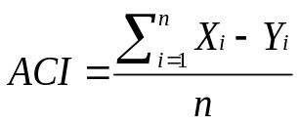
Figure 4.14 Average Competitive Interval Equation

Average Interval Difference (AID) is the average differences of a bidder’s competitive intervals. For example, if a bidder’s previous competitive interval is $20.00 and its current competitive interval is $30.00, the interval difference is $10.00. The average interval difference takes the average of the computed differences. If a bidder only places one bid in an auction, the AID value is set to 0.

A significant interval difference indicates a change in a user’s bidding behavior or valuation of the auctioned item. If a bid fight is occurring, where bidders are rapidly outbidding each other in efforts to be the high bidder, a high value of interval difference is likely to occur. If the difference is negative, it could indicate that the bidder does not want to raise the price of the auction too much but is willing to raise his valuation slightly to win the item. If the difference is positive, it could indicate that the bidder intends to stop the bid fight by placing a bid for his true valuation of the item, possibly deterring others from rapidly placing bids to be the high bidder.

A substantial value for AID could indicate efforts to raise the price of the auction, after seeing initial bidder interest. If the difference is negative and combined with a number of bids placed close together, it could indicate that the suspicious bidder does not want to scare off the currently active bidder and will participate in bid unmasking. If the difference is positive, it could indicate that the suspicious bidder sees no danger in raising the price significantly since there is enough time left in the auction to be outbid. A substantial, negative interval difference in the final stage could indicate a desire to stop raising the price of the auction as much but still place bids, after failing to substantially outbid everyone. Thus, it is appropriate to examine the time frame for this attribute. We present the equation to calculate this attribute in Figure 4.15, where X_{i} = user’s new high bid, Y_{i} = latest opponent’s high bid, X₀ – Y₀ = 0, n = total number of bids placed by the user in this stage, and n > 1. We divide by n-1 because there are n-1 changes in the bidding interval for n bids. Note that if n equals 1, this formula should return 0 since a change in bidding interval requires at least two bids.
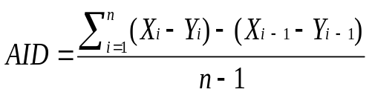
Figure 4.15 Average Interval Difference Equation
Average Time between User Bids (ATUB) refers to the average time that elapses between two bids placed by the same bidder. Since we try to identify aggressive bidders with this attribute, we define ATUB as the inverse of the average elapsed time between bids as follows in Figure 4.16, where T_{i} is the time of user’s bid, and n is the total number of bids placed by the user in this stage. Note that if n equals to 0 or 1, it returns 0 because the calculation of ATUB requires at least two bids.
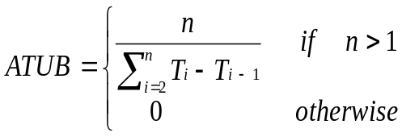
Figure 4.16 Average Time between User Bids Equation
A large value of ATUB indicates the bidder is actively participating in the auction, placing bids soon after they are outbid; while a small value of ATUB implies that the bidder is not participating heavily in the auction and is cautious before placing a new bid. A large value of ATUB in the early or middle stage indicates a suspicious bidder’s desire to raise the auction price and uncover the true valuations of other bidders, otherwise known as bid unmasking. For example, the proxy bidding system used at eBay facilitates the practice of bid unmasking because a new bid is immediately outbid if another user’s maximum bid is higher than the new bid. Therefore, a shill bidder can bait a proxy bidding system with small bids over the current high bid, and let the auction price quickly climb to other bidders’ true valuation [22].

On the other hand, a large value of ATUB in the final stage indicates a bidder’s strong desire to win the auction, because a bidder participating heavily in the final stage will likely win. In contrast, a shill bidder usually does not have a large value of ATUB in the final stage due to the risk of winning the auction. Therefore, it is important to examine both the stage and the value when examining ATUB.

Average Outbid Time (AOT) is the average time that elapses between when a user places a new high bid and when another user placed the previous high bid. For example, if a bidder placed a bid 20 seconds after another bidder placed a bid, the outbid time would be 20 seconds. A small value of AOT indicates a strong interest in the auction and participation in bid fighting, whereas a large value typically indicates passing interest in the auction or the bidder is evaluating the status of the auction before bidding, hoping to bid during a period of inactivity.

A substantially small value of AOT in the early stage may indicate a suspicious bidder’s desire to raise the price of the auction and uncover the true valuations of other bidders. On the other hand, a substantially small value of AOT in the final stage typically indicates a bidder’s strong desire to win the auction, as it is very likely that a bidder participating frequently in this stage of the auction will win. Thus, when examining AOT to determine whether a bidder is normal or suspicious, it is important to examine both the stage and the value. The equation for this value is displayed in Figure 4.17, where T_{i} = time of the user’s bid, U_{i} = time of the latest opponent’s high bid, and n = total number of bids placed by the user in this stage. A bidder that only places the first bid will have a value of 0 for this attribute.
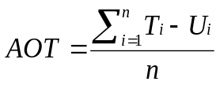
Figure 4.17 Average Outbid Time Equation
Number of Bids (NB) refers to the number of bids placed in a particular stage of the auction. A large value of NB at the early stage typically indicates a suspicious bidder’s desire to raise the price of the auction. A large value of NB at the middle stage could indicate suspicious behavior but not as strongly as a large value at the early stage. A suspicious bidder may attempt to uncover the true valuations of other bidders before the final stage, and a normal bidder may participate in a bid fight in the middle stage. A large value of NB at the final stage typically indicates a strong desire to win the auction. Due to the risk of winning the item, suspicious bidders typically do not participate at all in the final stage of an auction.

4.1.3 Auction attributes

Various properties of an auction may also influence a bidder’s decision to participate, and particular values of auction attributes may cast more suspicion on the trustworthiness of an auction as well as the likelihood of shill bidding taking place. We now give two examples of auction attributes as follows.

Auction Starting Price (ASP) may influence a bidder’s decision to participate in the auction. A high starting price can deter many bidders from participating in the auction, especially if they are bargain hunters. A low starting price combined with a very early bidder may indicate a seller’s attempt to avoid the additional fees associated with setting a high starting price.

[5] discussed the effects of the starting price on the possibility of an auction involving shills. It was concluded that an auction with a low starting price is more likely to involve reserve price shilling. Instead of setting a reserve price and paying additional fees, sellers can set a low starting price, place shill bids to raise the price up to an acceptable price, and profit. Thus, bidders that participate in auctions with a low starting price are more likely to be suspicious.

Seller Feedback Rating (SFR) is an important factor in determining the behavior of bidders in an auction. Some bidders are much more likely to bid in an auction if the seller has significant positive feedback [23, 24]. If a seller does not have a lot of positive feedback, it should be expected that not as many bidders will participate in the auction. However, as described by other researchers, SFR can be fabricated through fraudulent bidding rings, and thus cannot be entirely trusted to be accurate [4]. Thus we make the following conclusion: a suspicious bidder is more suspicious if it participates in an auction with a comparatively low SFR, but a suspicious bidder is not less suspicious if it participates in an auction with a high SFR.

4.2 Grouping Bidding Behavior using Hierarchical Clustering

Following the definitions provided in section 3.1, we can utilize the hierarchical clustering algorithm to create groups of bidders. To fully utilize the available domain knowledge, we first make use of weighted attribute values. Although the values for a dataset are normalized after analysis, we require that certain attributes have more emphasis than others. For instance, sellers with any feedback rating may participate in shill bidding, while bidders who place a lot of bids in the early stage are typically suspicious. Thus, certain attributes should be more important in determining cluster membership than others. By weighting the normalized values, two effects are realized. First, since the other values are either weighted from 0 to 1 or from -0.5 to +0.5, an attribute with a weight of 2 will range from 0 to 2 or -1 to +1. When utilized in the similarity measure calculations, these values will skew the similarity calculation in their direction, which is our objective. Secondly, weights also disperse values within a particular attribute. If two bidders were originally separated by a distance of 0.25 on their NB (early) value, a weight of 2 will cause them to be separated by a distance of 0.5 on that value. As a result, the two bidders are more likely to be in different clusters than without the weighted value. Because we want high values for particular attributes to stand out more so than others, applying weights to the normalized values allows us to accomplish this.

Once the clusters have been generated, we manually inspect each cluster to determine its classification of normal or suspicious. As an example, a cluster with an average value of 14 for NB (early) would definitely be classified as suspicious, whereas a cluster with an average value of 3 for NB (middle) would be classified as normal if its other average values weren’t too high. The largest cluster is always labeled as normal, since most of the bidders participating in online auctions are assumed to be regular bidders not participating in shill bidding. Clusters containing only one bidder, an outlier cluster, are always classified as suspicious, since these bidders deviate from the norms of every other larger cluster. Once a cluster has been labeled, the cluster’s label is applied to each of its bidders as their class label, either normal or suspicious.

Identifying Suspicious Bidders Using Decision Tree

After proper labeling, the generated clusters can be used as a training set for creating a decision tree. The creation process is discussed, in detail, in section 3.2. Once the decision tree is created, it can be used to classify new bidders in online auctions (i.e., to identify suspicious bidders immediately following the conclusion of an auction). If a suspicious bidder is detected, the corresponding account is put under further investigation for verification of shill bidding.

In the following section we demonstrate how a generated decision tree performs on a set of test data.

5.1 Experimental Results and Analysis

To demonstrate the feasibility of identifying suspicious bidders using hierarchical clustering and decision trees, we tested our methodology using real auction data from eBay.

The dataset we collected consists of completed eBay auctions for “Used Playstation 3.” This dataset was collected over the course of 30 days, contains 153 auctions with a total of 1,845 bidders and a duration of 1 day, and the estimated price of the auctioned item is $220.00 at the time of data collection.

Before the dataset can be processed for clustering, the attribute weights need to be specified. This is a subjective process based on the perceived importance of the attributes. The default weight for an attribute is 1. Certain attributes such as NB (early, middle), ETFB, and ATUB (early, middle) provide strong evidence that a bidder is suspicious, thus they are assigned a weight of 3. Attributes such as ACI provide evidence leaning toward a suspicious bidder but can also be attributed to normal behavior, thus ACI (early, middle) is assigned a weight of 2. All other attributes focus more on typically legitimate bidder behavior. For example, a bidder that places bids in the final stage is typically legitimate. As a result, such attributes are assigned the default weight of 1.

To validate our results, we utilize a 3-fold cross validation process. Each dataset is first divided into three equal portions – 2/3 of the dataset is used as a training set and 1/3 of the dataset is used a testing set. Then three complete sets of experiments are performed. The first experiment (called fold 1) consists of the first 1/3 of the dataset as the testing data, the second experiment (called fold 2) consists of the second 1/3 of the dataset as the testing data, and so on. The advantage of this method is that all data points are used for both training and validation, and each data point is used for validation exactly once.
We performed the clustering process twice for each fold: once on the training set, A, and another on the complete set A ∪ B, where B corresponds to a test set. The clusters generated from subset A are used in generation of a decision tree. The clusters generated from A ∪ B are used to find the correct clusters for test set B. Once the clusters are generated for A, they are labeled and passed to the decision tree algorithm as a training set. Meanwhile, test set B is extracted from the complete set, labeled, and passed to the decision tree algorithm for evaluation.

For this experiment, we determined that a minimum similarity cutoff point of 86.9% led to the best results; less restrictive cutoffs result in clusters that contained a mixture of normal bidders and suspicious bidders whereas more restrictive cutoffs result in multiple clusters that contained similar suspicious behavior. Table 5.1 presents the detailed cluster labeling for this dataset. Because the cluster labelings are similar for the other 2 folds, we omit the labeling results, but present the cluster summary in Table 5.2.
Table 5.1 Training Data Clusters for Fold 1
Cluster | Size | Class | Description
1 | 63% | Normal | Bids placed very late in auction (later middle stage or final stage).
2 | <1% | Highly Suspicious | Very high bidding amounts in middle stage.
3 | 4% | Suspicious | Bids placed close together in middle stage. Possible bid unmasking.
4 | 9% | Normal | Few bids placed in the middle stage of auction.
5 | 8% | Normal | Similar to cluster 4, but bids placed later in the middle stage.
6 | 1% | Suspicious | Bids placed fairly early in auction.
7 | <1% | Normal | Few bids placed in the middle stage of auction.
8 | <1% | Highly Suspicious | Highest bid amounts in the middle stage.
9 | 1% | Suspicious | Bids placed close together in the middle stage. Possible bid unmasking.
10 | <1% | Suspicious | Bids placed fairly early in auction and bids placed close together in the middle stage.
11 | <1% | Highly Suspicious | Bids placed in quickest succession in the middle stage. Possible bid unmasking.
12 | 11% | Suspicious | Bids placed very early in auction (early stage).
13 | <1% | Suspicious | Moderate number of bids in early stage.
14 | <1% | Suspicious | Bids placed close together in early stage. Possible bid unmasking.
15 | <1% | Highly Suspicious | Bids placed in quickest succession in the early stage. Possible bid unmasking.
16 | <1% | Highly Suspicious | Highest number of bids in the early stage.

Table 5.2 3-Fold Cluster Summary
Fold Number | Number of Clusters | Number of Outliers
Complete Set | 19 | 6
1 | 16 | 7
2 | 17 | 15
3 | 14 | 16

Once the clustering results have been generated and labeled, they are used to generate and test the decision trees. Due to overfitting concerns, the maximum depth of the decision trees is set to 3, and the minimum information gain is set to 10%. Figure 5.18 shows the decision tree generated for the fold 1 auction data set. Table 5.3 shows the decision tree performance results on the folds’ respective test set. Although the folds’ performance is relatively good, fold 3’s error rate is still double that of the other folds. Since there is no significant difference in the bidder distribution of each folds’ test set, there are few factors that could contribute to this phenomenon. One possible cause could be due to the presence of boundary values, bidders that could be classified as either normal or suspicious, in fold 3’s testing set. This would explain the decision tree’s difficulty in classification, since it was presented with a more difficult testing set. As can be seen in Figure 5.1, a decision tree is not designed to consider all available evidence when presented with a difficult decision; if a bidder had placed two bids within 9 seconds of each other, 13 hours after the start of the auction, fold 1’s decision tree would classify that bidder as normal – a very probable misclassification. The inability to classify boundary values detracts significantly from a decision tree’s ability to correctly classify bidder behavior. Even though the experiment results show that decision trees perform adequately, the results are further motivation to utilize more effective classifiers, such as neural networks.
ETFB
ACI(Middle)
N
≈ 1 day
ACI (early)
≤ 1
75 ≥ x > 1
1 day > x > 12 hours
ATUB(Middle)
NB (Middle)
S
0
N
≥ 1
N
≤ 1
S
> 1
HS
> 75
≤ 12 hours
8s ≥ x > 0
>8s
0
N
N
S
Figure 5.18 Decision Tree for Fold 1

Table 5.3 Decision Tree Results
Fold | Training Set | Testing Set Size | Test Results
1 | 81% Normal  18% Suspicious  1% Highly Suspicious | 614 data points | 94% Correct  6% Incorrect
2 | 77% Normal  21% Suspicious  2% Highly Suspicious | 614 data points | 94% Correct  6% Incorrect
3 | 81% Normal  17% Suspicious  2% Highly Suspicious | 614 data points | 87% Correct  13% Incorrect

A Framework for Real-Time Self-Adaptive Classifier

The real-time self-adaptive classification process is shown in Figure 6.19 and an algorithmic view of this process is shown in Figure 6.20. When new auction data comes in, the participating bidders’ attributes are processed Based on the processed bidders’ attributes, the system first checks if there any outliers. Outliers can have significant negative effects on classifier training performance. If the network is trained frequently on outliers, the network will then begin to expect that bidders typically act in such a manner. For example, if the network is regularly trained on suspicious bidders that bid more than 15 times in an auction, the network may then begin to assume that bidders that bid less than 15 times in an auction are not suspicious. Since most bidders bid no more than 3 times in an auction, this is clearly an unreasonable assumption made by the network. Thus, it is important to correctly determine which bidders are outliers. We consider a bidder an outlier if any of its attribute values are more than 5 standard deviations from the average for that attribute. For example, if the average number of bids is 2 with a standard deviation of 1, we consider a bidder that placed 10 bids in an auction as an outlier.

Regardless of a bidder’s status as an outlier, it is sent to the neural network for classification. If the network classifies any bidders as suspicious, the bidders are sent to an external verifier for further investigation. The verifier will always return the verification results to the classifier, so that the network is correctly trained on any possible false positives. If the classifier did not make use of the corrected results from the verifier, the network would then adapt to incorrect examples of suspicious bidding behavior. This would possibly confuse the classifier and, in the worst case, eventually lead to a severe degradation in the classifier’s performance. Note that this scheme does not handle the presence of false negatives (i.e., suspicious bidders classified as normal). Although the classifier is unable to correct itself on false negatives, we can adjust how skeptically it classifies bidders. If we notice that the classifier is classifying very few bidders as suspicious or it produces many false negatives on a testing procedure, we can adjust a decision function in such a way that it will classify more bidders as suspicious. For example, if the classifier displays some uncertainty in whether a bidder is normal or suspicious, we can adjust the function such that it will always classify these types of bidders as suspicious. We discuss this function in more detail in section 6.1.

If a bidder is detected as an outlier, it is dropped from the dataset. The rest of the bidders are used by the Selection and Replacement (SR) module to replace data in the data pool and to create a training set and a validation set for the next network training phase. Before doing so, the SR module will normalize the new bidders against the current data pool. This normalization procedure consists of calculating the maximum value for every attribute and then dividing each new bidder’s value for that attribute by the calculated maximum value. For example, if out of all the new bidders and the bidder’s in the data pool, the maximum value for NB (middle) is 10, then each new bidder will have its value for NB (middle) divided by 10. After the normalization and data pool replacement, the SR module uses the latest window of bidders from the current data pool in the creation of the training and validation set. We illustrate this window abstraction in Figure 6.21. If we define the window size to be 9, then the SR module will use the latest 9 bidders, including the bidders that were recently added to the data pool, to create a training and validation set.

Once the Real-Time Training (RTT) module adapts the existing network using these sets, the classifier is updated for the next classification and training phase. Note that the SR and RTT modules always utilize the Knowledge Base’s rules to make decisions on their various responsibilities.
Normal
Non-Outliers
Selection/Replacement Module
New Auction
Adaptive NN
(k)
Adaptive NN
(k+1)
Real-Time Training Module
Data Pool
Knowledge Base
Verifier
Update
Suspicious
Selection Rules
Training Rules
Train, Validation Sets
Classification Results
Set Creation
Outlier Detection
Data Pool Replacement
Replacement Rules
Non-Outliers
Outlier Rules
New Bidders
Bidders
Creates
RT-SAC
Figure 6.19 Architectural Design of Real-Time Self-Adaptive Classifier
processNewBidders(Set newAuction)
initialize noOutlierSet to empty
For each Bidder b in newAuction
if(srModule.isOutlier(b) == false)
add b to noOutlierSet
if b is classified as suspicious
label b with the class outputted by verifier’s investigation
else
label b as normal
srModule.replaceElements(newAuction)
[trainingSet, validationSet] = srModule.selectTrainingAndValidationSet(noOutlierSet)
rttModule.adaptNeuralNetwork(trainingSet,validationSet)

Figure 6.20 New Auction Data Processing Algorithm

Simulation Dataset
Data Pool
Historical Data Points
1
2
3
4
5
6
7
8
9
10
11
12
13
Window
Figure 6.21 Graphical Representation of a Window

6.1 RT-SAC’s Neural Network Output Decision Function

To handle the issue of false negatives that was discussed earlier in section 6, we define a decision function that allows us to adjust how untrusting the neural network is of bidders. When the neural network produces output at its output neurons, the output is in the form of a real number from -1 to +1. The neuron that has the highest output value will be determined the winner and thus determine a bidder’s classification as normal, if the normal neuron was the winner, or suspicious. We further modify this basic concept to interpret the output as degrees of certainty. For instance, if both neurons output a value of +0.6, we interpret this as the neural network being unsure as to whether the bidder is normal or suspicious. In addition, we also interpret uncertainty if the neural network outputs two negative numbers. In cases of uncertainty, we instruct the classifier to interpret the uncertainty as a suspicious classification. Although this may seem harsh, these cases are rare enough such that it will not produce too many false positives. By doing so, we can reduce the number of potentially harmful false negatives in favor of insignificantly increasing the number of harmless false positives.

6.2 Design of Selection and Replacement Rules for Reasoning

The Selection and Replacement (SR) module makes decisions on outlier detection, replacement of data points in the data pool, and creation of training, validation, and testing datasets. The SR module’s set creation procedures involve purposefully selecting certain bidders from the data pool and can also involve maintaining a class distribution, a proportion of normal and suspicious bidders, within the created sets. For example, the SR module may need to create a training set that contains all of the new bidders in an auction, all bidders that were involved in today’s auctions, and ensure that there are an equal amount of normal and suspicious bidders in the training set.

This decision making process is implemented by defining a set of rules in Prolog. These rules, stored in a central knowledge base, allow the module to make a simple query to a Prolog engine. For example, if the SR module needs to know if a particular bidder is an outlier or not, it can make a query to a defined rule and receive an interpretable response of yes or no. What makes this approach dynamic is that these rules can be stored in a separate module, so it is possible for human users to modify existing rules and conditions without having to interrupt the operation of the classifier. The following sections describe the SR module’s responsibilities in more detail.

6.2.1 Outlier Detection

Statistical outliers, elements of a set that have significantly different values than the majority of the set, are a topic of debate in many fields. [25] discusses, in great detail, the potential causes and interpretations of outliers. Furthermore, it discusses the often adverse effects that outliers can have on error rates. Regardless of whether the outliers are legitimate members of the sampled population or if they are due to sampling error, removal of outliers in most scenarios leads to improvements in error rate.

To compensate for errors in the classification process, we mark bidders as outliers before classification. For example if a bidder is incorrectly classified, then it is unlikely that its behavior will be similar enough to the wrong class to be kept in the data pool; if a bidder is actually normal, then its values will most likely mark it as an outlier when compared only with suspicious bidders. Since this bidder may have been a good example of a normal bidder, we want to avoid this type of situation. Note that all bidders, regardless of their status as an outlier, will be classified and sent to the verifier if classified as suspicious. A bidder’s status as an outlier only affects their presence in the system after classification. Bidders that are not marked as outliers are eligible for use by the SR module in creating training and validation sets and will also added to the data pool for future use.

To determine whether a data point is an outlier, we implemented a Prolog rule, which will allow dynamic adjustments to this process. Because we do not use a bidder’s classification when determining if it is an outlier, each bidder will be compared with all bidders in the data pool. We consider a bidder to be an outlier if it possesses a value for an attribute that is significantly different than other bidders’ value for that attribute. We consider a value to be significantly different if it is more than 5 standard deviations away from the mean. This threshold of 5 standard deviations is adjustable, since it is defined using a Prolog rule. The advantage of using Prolog rules is to allow implementation of different standards for outlier detection, without modifying the source code of the classifier. An example of such a rule is presented in Figure 6.22.

The SR module can invoke the “isOutlier” rule, with the parameter of the bidder’s ID. The engine then analyzes if there is a solution to “standardDeviationThresholdExceeded” for the bidder. To determine this, the engine invokes a method that accesses an external Java library class called “DatasetManager” and a method that calculates the number of standard deviations the bidder is away from the mean of all other bidders in the data pool. Once the method returns the result “V”, the engine compares V with a defined threshold, 5.0. If a bidder has an attribute value that is more than 5 standard deviations away from the mean for that attribute, the rule “isOutlier” evaluates to true, signaling to the SR module that the bidder is an outlier.

isOutlier(B) :- standardDeviationThresholdExceeded(B).
standardDeviationThresholdExceeded(B) :- dataConnect(B,V), analyzeThresholdResult(V,5.0).
dataConnect(B,V) :- class('io.DatasetManager') <- getNumStandardDeviationsAwayFromMean(B) returns V.
analyzeThresholdResult(V,X):- V > X.
Figure 6.22 Outlier Detection Rule

Possible expansions on this rule could include a quartile analysis on the bidder, simply by adding a sub-rule that is called by “isOutlier”. If an expansion is difficult to program using Prolog or there is additional information required that is not initially passed to the engine, it is possible to utilize or modify an external library, such as DatasetManager, to perform the difficult computations or lookup the additional information.

6.2.2 Creation of Training and Validation Datasets

Creating training and validation sets is not a simple process, since it greatly affects the training performance of a neural network. If a training or validation set is not representative of the entire dataset, the network will adjust its weights and bias in such a way that worsens its overall performance. It is also important for the sets to contain recent data. If the classifier is trained on outdated representations of normal and suspicious bidders, the classifier may lose its ability to correctly classify recent data. In addition to recent data being used in the set, it is important to decide how much recent data is utilized. If there is an overwhelming number of previously classified data in the training set, the network will adapt slowly to the latest auction data, eventually compromising the network’s ability to classify new auctions.

We also define a rule to determine the optimal size of the training and validation sets. The training set will contain 75% of eligible bidders and the validation set will contain 25% of eligible bidders, which effectively removes the possibility of overlap between these two sets. Overlapping elements are more likely to be classified correctly, since the training procedure modifies the network’s weights in such a way that all training elements will be correctly classified. As a result, a validation set with overlapping elements will not be useful for determining how the network will classify new elements (elements not in the training data). By disallowing overlap, we ensure that a validation set can be evaluated as an unbiased indicator of the network’s true performance. We present the Prolog facts for use in this set creation process in Figure 6.23.
trainingProportion(T):- T is 75.
validationProportion(V):- V is 25.
windowSize(W):- W is 9.
Figure 6.23 Set Creation Facts

6.2.3 Data Pool Replacement Policies

Data pool replacement policies are concerned with replacing elements of the data pool with new elements. Because the size of the data pool could become oppressively large over time, it is necessary to periodically remove data from the pool. In addition to size concerns, it is also necessary to ensure that testing sets are created based on the most recent data. If the classifier correctly classifies recent auctions, it may not necessarily classify very old auctions correctly. In this case, if the testing set contains outdated data, it may give an inaccurate depiction (very low accuracy in this case) of the classifier’s current performance. The issue of choosing whether to replace a data element and which data element to replace is solved by appropriate replacement policies.

When replacing bidders in the data pool, it is necessary to maintain a balanced proportion of normal and suspicious bidders. As shown in the case study, the majority of bidders are normal bidders. If we simply replace the oldest bidder with the newest bidder, it is likely that the majority of the data pool will be normal bidders. If the SR module needs to create a testing set to evaluate the performance of the network, it will likely retrieve a testing set comprised solely of normal bidders. Regardless of the results of the testing process, we will not have an accurate representation of how well the network classifies suspicious bidders. Thus, it is necessary to ensure a balanced proportion of normal and suspicious bidders in the data pool. The current replacement policy will consider the oldest bidders for replacement when adding new bidders to the data pool. Figure 6.24 shows an example of the replacement policies.

The SR module invokes the “replaceBidder” rule, with the parameters of the bidder’s ID “B” and the bidder’s classification “C”. The last variable, “R”, is left as a return variable, so the SR module will receive a bidder ID if the engine finds a solution. The engine will access an external Java library class called “DatasetManager” and a method that performs a lookup for the oldest bidder with matching classification in the data pool. The method will return the bidder ID in the variable “R”, and the engine will return the bidder ID to the SR module.

replaceBidder(B,C,R):- replaceOldestBidderWithMatchingClassification(C,R).
replaceOldestBidderWithMatchingClassification(C,R):-class('io.DatasetManager') <- retrieveOldestBidderWithClassification(C) returns R.
Figure 6.24 Data Pool Replacement Policy Rule

Possible expansions on this rule could include additional analysis on the current class distribution of the data pool; if the data pool does not contain enough suspicious bidders, the engine could rule that the oldest normal bidder should be replaced, even if the current bidder is suspicious. This way, if the initial distribution of the data pool is not balanced enough, the replacement policy could serve to even the distribution. In addition, a maximum pool size could be enforced through a Prolog rule by defining an additional DatasetManager method to retrieve the current size of the data pool.

6.3 Design of Rules for Real-Time Training

The RTT module is responsible for ensuring that any training that takes place is beneficial to the health of the classifier. By utilizing stopping rules to determine whether the current training cycle of the network is complete, the module can ensure that each training cycle leads to the network’s gradual, yet timely, adaptation to new data. If the stopping conditions are improperly defined, the training cycle may finish very quickly or never finish at all. As a result, it is very important to make informed decisions about stopping conditions. There are common stopping rules in use by other researchers for neural networks. For example, [19] utilizes a wide variety of stopping conditions, including a minimum and maximum number of training iterations (epochs), an acceptable training error threshold, and an acceptable validation error threshold. [20] mentions the usage of convergence detection as a stopping condition. Examples of these rules are adopted in our approach and are discussed in more detail and represented in Prolog in Figure 13 at the end of the section. Possible expansions on these stopping rules can include those used by [21]. Minimum square error is yet another possible stopping condition that can be implemented for use by the classifier.

Because training can potentially never end, it is important to define a maximum number of epochs that can take place, especially since we require our classifier to function as a real-time system. For our purposes, a maximum of 5,000 iterations can complete in a reasonable amount of time without significantly sacrificing performance. Note that while this number is high, it is rarely ever reached, due to the other stopping conditions. To avoid possible overfitting, we also define other stopping conditions.

Too many epochs can lead to overfitting since the training process continually presents the same examples to the network repeatedly. However, too few epochs can lead to underfitting since the network does not have sufficient time to learn the training data. As a result, we make use of a minimum term that must evaluate to true in order to finish training. If the classifier already has excellent performance, it is possible that the network will correctly classify created training or validation sets without training. This becomes an issue when we are trying to adapt the network to new data points within the training set. If the network never trains on the set it is presented with because it classifies most of the validation set correctly in the first epoch, then the network will never adapt to classify new data. As a result, even if the other stopping conditions are met, the training process will not stop until the minimum number of epochs has been reached. For our approach, we impose a minimum of 100 training epochs.

As previously discussed, we utilize validation sets to ensure that the classifier’s performance on a non-overlapping set is sufficient. . If the RTT module stops training as soon as the training set is correctly classified, it is possible that the neural network will not correctly classify any other data. As a result, we make use of a non-overlapping validation set to evaluate the network’s training progress. By defining a threshold for validation error, the training procedure will stop if the network can correctly classify 90% of the validation set.

Although validation performance is a good indicator of whether or not the training process is completed, it is possible that the validation performance will never improve despite continued iterations on the training set. The training process will continue until the maximum number of epochs is reached and then end. However, if the validation performance stops improving early in the training cycle, it is likely that the network will be overfitted to the training data, and the performance on the validation data will worsen. As a result, we make use of a convergence detection term. If the network’s performance on the validation set does not improve after 100 consecutive iterations, the RTT module decides that the performance will not improve any further and discontinues training before the network is too heavily overfitted on the training data. Figure 6.25 lists the main stopping condition rule and its sub-rules, which were discussed in this section.
isFinishedTraining(E,V,I):- maxEpochExceeded(E,C).
isFinishedTraining(E,V,I):- validationPerformanceAcceptable(V), minimumEpochExceeded(E).
isFinishedTraining(E,V,I):- validationImprovementLimitReached(I).
maxEpochExceeded(E,C):- E >= 5000.
minimumEpochExceeded(E):- E >= 100.
validationPerformanceAcceptable(V):- V >= 90.
validationImprovementLimitReached(I):- I >= 100.
Figure 6.25 Stopping Conditions Rule

RT-SAC Case Study

In the following case study, we present a series of experiments designed to demonstrate the feasibility and performance of our classification framework.

In the following sections, we first discuss about the datasets used in all experiments and summarize the results of using hierarchical clustering for creating the training datasets. Then we present the neural network implementation utilized in RT-SAC and discuss about its advantages over other neural network implementations. Finally, we present the experimental results and analysis.

7.1 Data Collection and Preprocessing

We collected two separate datasets for the purposes of demonstrating the classifier’s ability to adapt to new auction data. Both datasets consist of completed 1-day eBay auctions for “Used Playstation 3.” Dataset 1 was collected over 30 days and contains 153 auctions with a total of 1,845 bidders. Dataset 2 was collected over a period of 2 days and contains 23 auctions with a total of 180 bidders. The two datasets were collected from October 20, 2009 to November 20, 2009, and from May 6, 2010 to May 7, 2010, respectively. During this 6 month period, the number of 1-day auctions for “Used Playstation 3” dropped drastically, as most of the auctions recently available were for 3 or 5-day auctions. [26] makes various observations regarding the effect that auction duration has on bidder behavior. As a result, we do not include multiple auction durations in any dataset; our datasets only contain auctions with a duration of 1-day.

Overall, the two datasets contain similar behavior. However, there is a slight difference concerning the number of bids placed by the bidders in the datasets. 57% of bidders in dataset 1 and 48% of bidders in dataset 2 place only one bid in the auction. Although 9% may not seem like a significant difference, dataset 2 contains a 4% increase in the number of bidders that place more than 5 bids in an auction. Since more than 80% of bidders in either set place no more than 3 bids in an auction, we consider placing 5 bids in an auction to be abnormal behavior. In addition to this difference, bidders in dataset 2 place their first bid, on average, 47 minutes earlier in the auction; since we also consider bidding early in an auction to be more suspicious the earlier it takes place, this feature is also of interest. Despite these differences, we do not expect the classifier to have too much trouble adapting to dataset 2.

Before running the hierarchical clustering algorithm described in section 3.1, we assign weights to the various attributes. By default, an attribute’s weight is 1. We deem the NB (early, middle), ETFB, and ATUB (early, middle) attributes to be the most important evidence for suspicious behavior, and we assign these attributes a weight of 3. ACI (early, middle), although useful in describing how aggressive a bidder is, is not as strong an attribute as the weight 3 attributes, thus we assign this attribute a weight of 2. Other attributes are more useful for describing legitimate bidder behavior than suspicious behavior. Bidders that act in the final stage, for example, are typically legitimate bidders; attributes that examine final stage behavior are more useful for describing how legitimate a bidder is behaving. As a result, these other attributes are assigned the default weight of 1.

To aid in the manual cluster labeling process, we utilized the HCE software to visualize the hierarchical clustering process [27]. After running the algorithm and examining the results, we determined that a minimum similarity cutoff point of 89.6% lead to optimal results. More restrictive cutoff values led to more clusters with similar behavior and less restrictive cutoff values led to clusters containing a combination of normal and suspicious behavior.

Upon examining the generated clusters, we observed that the bidder behavior could be categorized into one of three categories: normal, suspicious, or highly suspicious. For simplicity purposes and to make the classification process for the neural network easier, we treat suspicious and highly suspicious bidders equally. This simplification does not detract from the utility of the classifier, as the verifier will receive bidders classified as suspicious or highly suspicious; it makes no difference to the verifier whether it receives a bidder marked as suspicious or highly suspicious. Table 1 and 2 display the manual labeling results in further detail. Note that most of the suspicious activity listed in the table can be directly linked to shilling behavior described in [9]. Furthermore, we utilize the Dempster-Shafer rules described in [5] to verify the results of the labeling process.
Table 7.4 Cluster Labeling for Dataset 1
Cluster | Size | Class | Description
1 | 62% | Normal | Bids placed very late in auction (later middle stage or final stage).
2 | <1% | Highly Suspicious | Very high bidding amounts in middle stage.
3 | 2% | Suspicious | Bids placed close together in middle stage. Possible bid unmasking.
4 | 1% | Suspicious | Bids placed close together in middle stage. Possible bid unmasking.
5 | <1% | Suspicious | High number of bids in middle stage.
6 | <1% | Highly Suspicious | Bids placed in quickest succession in middle stage. Possible bid unmasking.
7 | <1% | Highly Suspicious | Bids placed in quickest succession in middle stage. Possible bid unmasking.
8 | 8% | Normal | Few bids placed in middle stage.
9 | 1% | Normal | One bid placed in middle stage.
10 | <1% | Suspicious | Moderate bidding amount in middle stage.
11 | <1% | Suspicious | Moderate number of bids placed in middle stage.
12 | <1% | Suspicious | Moderate number of bids placed at the end of middle stage.
13 | 8% | Normal | Few bids placed in middle of auction.
14 | 1% | Suspicious | Bids placed moderately early in auction.
15 | <1% | Suspicious | Bids placed for moderate amounts and moderately early in auction.
16 | <1% | Suspicious | Bids placed moderately early and throughout auction.
17 | <1% | Suspicious | Bids placed moderately early and throughout auction.
18 | <1% | Suspicious | Bids placed moderately early and in quick succession in early stage. Possible bid unmasking.
19 | 2% | Suspicious | Bids placed in quick succession in middle stage.
20 | <1% | Suspicious | Bids placed in quick succession in middle stage.
21 | <1% | Suspicious | Bids placed in quick succession in middle stage.
22 | <1% | Suspicious | Bids placed in quick succession in middle stage.
23 | <1% | Highly Suspicious | Bids placed in quickest succession in middle stage.
24 | <1% | Highly Suspicious | Bids placed in quickest succession in middle stage.
25 | <1% | Highly Suspicious | Highest bidding amount in middle stage.
26 | 9% | Suspicious | Bids placed moderately early in auction.
27 | <1% | Suspicious | Bids placed moderately early in and in quick succession in early stage. Possible bid unmasking.
28 | 1% | Suspicious | Bids placed moderately early and for moderate amounts in early stage.
29 | <1% | Normal | Few bids placed in early stage.
30 | 1% | Suspicious | Moderate number of bids placed in early stage.
31 | <1% | Suspicious | Bids placed in quick succession in early stage.
32 | <1% | Highly Suspicious | Bids placed in quickest succession in early stage.
33 | <1% | Highly Suspicious | Highest number of bids placed in early stage.

Table 7.5 Cluster Labeling for Dataset 2
Cluster | Size | Class | Description
1 | 42% | Normal | Bids placed very late in auction (later middle stage or final stage).
2 | 13% | Normal | Few bids placed in middle of auction.
3 | 2% | Suspicious | Moderate bidding amount in middle stage.
4 | 1% | Normal | Few bids placed in middle of auction.
5 | 5% | Suspicious | Moderate number of bids placed in quick succession in middle of auction. Possible bid unmasking.
6 | 1% | Suspicious | Bids placed in quick succession in middle stage. Possible bid unmasking.
7 | 3% | Highly Suspicious | Bids placed in quickest succession in middle stage. Possible bid unmasking.
8 | 3% | Suspicious | Moderate number of bids placed in middle of auction.
9 | 1% | Highly Suspicious | High number of bids placed in middle stage.
10 | 11% | Suspicious | Bids placed moderately early in auction.
11 | 4% | Normal | Bids placed throughout auction.
12 | 1% | Suspicious | Bids placed moderately early in auction.
13 | 1% | Suspicious | Moderate bidding amount in middle stage.
14 | 1% | Highly Suspicious | Highest bidding amount in middle stage.

7.2 Implementation of Self-Adaptive Neural Network

Although neural networks and backpropagation algorithms have been successfully utilized in previously described related work, there are still distinct advantages and disadvantages to consider [28]. Some concerns about computational complexity, methodology, and generalization are of primary importance to our approach. Because we want our classifier to efficiently and accurately classify and adapt to new bidding data, it is necessary to carefully examine the efficiency of any training algorithms we use, the creation process for any training and validation sets, and the effectiveness of stopping conditions and other chosen parameters for our classification and training process.

Because we require that our classifier run in real-time, it is of utmost importance that we choose an efficient learning algorithm, efficient network implementation, and keep the incremental training samples small. The resilient backpropagation algorithm, as described in section 3.3.1, has been empirically evaluated to significantly outperform other popular backpropagation algorithms [18].

Although the learning algorithm we utilize is efficient, it is still necessary to implement the algorithm properly such that the computation time is realistic for use in a real-time environment. The Encog project is an advanced machine learning platform that provides efficient multi-threaded implementations of various neural network learning algorithms, including resilient backpropagation [29]. By utilizing the Encog implementation of the neural network, the classifier framework can classify and train on a single auction in anywhere from .5 to .8 seconds. Furthermore, this time performance result was obtained when running on a 2.1 GHz dual-core processor with 3.0 GB of RAM – a relatively modest system when compared to a dedicated server or computing mainframe.

In addition to the time efficiency introduced by Encog, we also utilize small, incremental training and validation sets. By adapting the network incrementally, we eliminate the need to train the network on a large set of data at one time, which would lead to an increase in computation time. The incremental adaptation also allows the network to not immediately forget what it has learned from previous training runs. This approach has been used successfully in [13, 14], and we will demonstrate in the case study that the network retains a significant portion of its accuracy on historical data, even when it has been trained on a number of newer auctions.

Concerns about methodology primarily question the values for the various parameters utilized by standard backpropagation algorithms. Due to the resilient backpropagation algorithm we utilize, the main consideration is choosing the appropriate number of hidden neurons. We found the optimal number of hidden neurons through repeated experimentation and analysis. Other potential variables such as the initial update values and step factors are not sensitive to a “correct” value. One of the main advantages of the resilient backpropagation algorithm is that its few variables require no parameter tuning to achieve optimal results [18].

The problem of ensuring classifier generalization is not unique to neural networks. If a classifier is able to correctly classify its training data but performs very poorly on a separate validation or testing dataset, the classifier is said to be overfitted on its training data. Decision trees, another type of classifier, are also prone to overfitting, and there are various methods to overcome overfitting, including early stopping, cross-validation, and post-pruning [30]. Common techniques for neural networks include early stopping, cross-validation, and weight decay. However, [31] describes the surprising difficulty in overfitting neural networks to their training data. Although their results may indicate that this should not be a concern, we still take the possibility of overfitting into account in our process. Thus, we utilize the early stopping conditions described in section 6.3, which include a performance threshold on a disjoint validation set and a maximum number of training iterations.

7.3 RT-SAC Experiments Results and Analysis

7.3.1 Simulations of Real-Time Training and Classification

Our simulation procedures are designed to effectively test the classifier’s performance when it is presented with new data. We are primarily concerned with ensuring that the classifier maintains a relatively low error rate, steadily approaches lower error rates, and performs its classification and training procedures quickly enough for use in a real-time environment.

First, dataset 1 is sorted by auction end time and divided into two portions: an initialization set that contains the first 135 auctions and a simulation set that contains the last 18 auctions. The initialization set is used for training, validation, and testing of the newly created network. It is important that the dataset used for initializing the network is large and representative enough so that the network has a sufficient baseline to correctly classify future data. The initialization set is then further divided into training, validation, and testing sets: the testing set contains 25% of all the normal bidders and 25% of all the suspicious bidders in the initialization set and the combined training and validation set contain the rest of the data. The combined training and validation set are processed for outliers by the SR module, normalized, split into training and validation sets by the SR module, and then sent to the RTT module for training. Once a network has been created, the testing dataset is used as the data pool’s baseline; future evaluations on how the network classifies the initial data will use data from this portion of the data pool.

After the network and data pool have been initialized, the aforementioned simulation set can be processed by the classifier. The classifier will utilize the workflow described in section 6 and process each auction in the sorted simulation set in sequential order. First, the auction is processed for outliers and any detected outliers are marked as such, using the process described in section 6.2.1. Regardless of outlier status, every bidder will be sent to the neural network for classification, once the classifier marks the outliers in the current auction. Any suspicious bidders are immediately sent to a verifier for further investigations. If the verifier classifies any suspicious bidders as non-shill suspects, it will inform the classifier of the updated classification. If any shill suspects are detected, the auction transaction may be canceled. Next, any previously detected outliers are discarded from the simulation dataset, since only non-outliers are eligible to be used for training the network, as discussed in section 6.

In order to fully visualize the adaptation trend of the network, we process the eligible, classified bidders in groups of 3. This number can be thought of as a window speed that determines how fast the window will phase data in and out of itself. By setting a slow speed, the network will exhibit a more gradual adaptation to the data, since it has time to fully process all bidders that pass through it. It is important not to set too fast or too slow of a speed. Too slow of a speed may cause overfitting, since bidders will be reused for training too much; too fast of a speed will cause underfitting because the network doesn’t have sufficient time to learn the bidders in the window. The current group of 3 bidders is normalized with the current data pool contents, as discussed in section 6, and then sent to the SR module to be added to the data pool. At this point, the oldest bidders with matching classifications to these new bidders are removed from the data pool to make room for the new bidders; if there are 3 new suspicious bidders being added to the data pool, the SR module will remove the 3 oldest suspicious bidders from the data pool. The SR module then creates training and validation sets from the latest 9 bidders, the current window, in the data pool; 7 bidders will be in the training set and 2 bidders will be in the validation set. The RTT module will then use these training and validation sets to adapt the current network. It will always perform at least 100 training iterations before checking other stopping conditions to halt training. Once training is completed, the classifier will create two test sets to evaluate the performance of the network. The first test set is created from previously processed data that is not in the current window. For example, if there are more than 9 bidders from the simulation dataset that have been processed, these other bidders will be used in the test set. Note that if 9 bidders have not been processed yet, the testing process will be skipped, since any test sets that will be created will contain data that was just used in training; any signs of recent overfitting will not be detected in such a testing set. The second test set is the same size as the first test set and contains the oldest bidders stored in the data pool that are not from the simulation dataset. This procedure repeats until all of the auctions in the simulation dataset have been processed.

7.3.2 Experiments for Parameter Tuning

As discussed in [18], the resilient backpropagation algorithm’s few parameters are insensitive to tuning and thus do not require this process. However, other parameters in our process are sensitive to tuning and benefit from additional tuning. The following parameter tuning experiments focus on finding the optimal values for the window size, outlier threshold, and hidden neuron count. Because we are mainly interested in how the parameter tuning process affects the adaptation rate of new data, each of the following experiments utilizes the simulation procedure and datasets described in section 7.3.1. Each result displayed is in terms of combined total error rate for the initialization dataset and the simulation dataset. By doing so, we can be assured that a low error rate means the network is learning the new data and not completely forgetting the old data. The formula for this calculation is displayed in Figure 7.1, where i = size of initialization dataset, e_{i} = error rate of initialization dataset, s = size of simulation dataset, and e_{s} = error rate of simulation dataset.

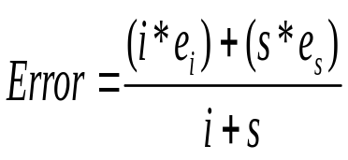
Figure 7.26 Combined Error Rate Equation

The parameters in question are loosely dependent on each other. For instance, the number of hidden neurons is likely to influence how quickly the network converges on a solution and how well it utilizes its current training window. On the other hand, the choice of training window is likely to determine how many hidden neurons are necessary to optimally converge on a solution. Also, a small training window will likely be skewed by the existence of an outlier, but a small training window can also cause an outlier to be phased out of the training process earlier, limiting the amount of damage it can do to the network’s performance. In reality, the training process largely determines how much impact each parameter has on the network’s performance. While tuning the parameters, we noticed that by tweaking the value for one parameter, the performance in all other experiments improved, without changing the previously optimal value for the other parameters. For example, an outlier threshold of 3.0 is typically a good threshold to use for any application regarding outlier removal. If an optimal value for hidden neurons is found and the outlier threshold experiment is rerun with that optimized value for hidden neurons, the results in the outlier threshold experiment improve as well, with the optimal threshold value unchanged.

Window Size

The window size parameter discussed in section 6 is an important parameter for the simulation process. A window size that is too small may cause the network to overfit, since it is being trained on a limited view of the dataset. A window size that is too large may slow the adaptation of the network to the most recent auctions or increase the time required to complete a training iteration. For this experiment, we ran the simulation with window sizes of 3, 6, 9, and 12. Figure 7.27 displays the combined total error rates for every 3 bidders processed in the simulation dataset.

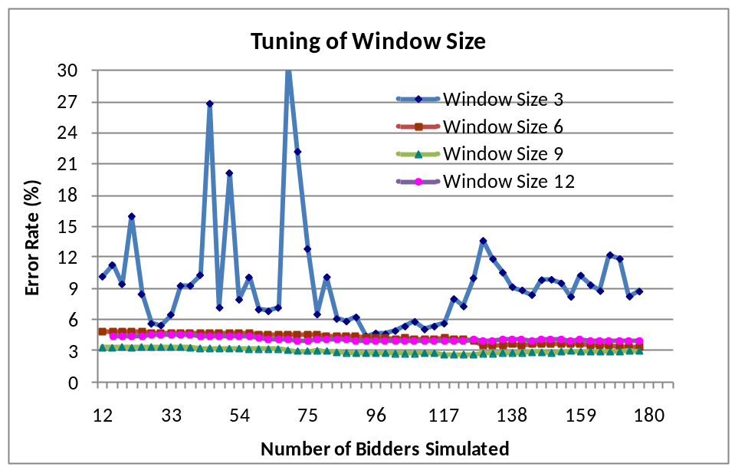
Figure 7.27 Experimental Results for Tuning of Window Size
The window size of 3 is especially terrible due to the training process we use: process 3 bidders at a time. Since the window size is 3, there is no previously trained new data to use in the window; the training and validation set will only consist of the current 3 bidders being processed. This leads to significant fluctuations in error, as the training module never gets a good training/validation set. The window size of 9 seems to be the best; 75% of the training/validation set is previous data and 25% is the current 3 bidders. For a window size of 9, the algorithm quickly converges on a solution, since the current auction has a lot of emphasis on the training process, but this emphasis is balanced out nicely by previously processed data. In addition to the window balancing effect, the window speed of 3 will cause each bidder to be used three times for a window size of 9. This allows the network more time to effectively learn the data, whereas a window size of 3 does not give the network enough time.

Also worth noting is that the error rates for a window size of 6 and 12 do not appear to differ significantly from a window size of 9. Bidders in the smaller window size of 6 are used twice, which does not give the network optimal time to learn the data and is a sign of underfitting. Bidders in the larger window size of 12 are used 4 times, potentially leading to overfitting if bidders are reused too often. As a result, it is important to choose a window size that will optimally fit the data, in this case a window size of 9.

Outlier Threshold

As described in section 6, outlier detection is an important processing step for the classifier. However, it is not immediately clear what threshold to set for a bidder to be classified as an outlier. This experiment is designed to demonstrate the consequence of choosing a threshold that is either too low or too high. We ran the experiment for standard deviation threshold values of 3, 5, and 7. We also analyze the classifier performance when outliers are not removed from the dataset. The results are displayed in Figure 7.28.

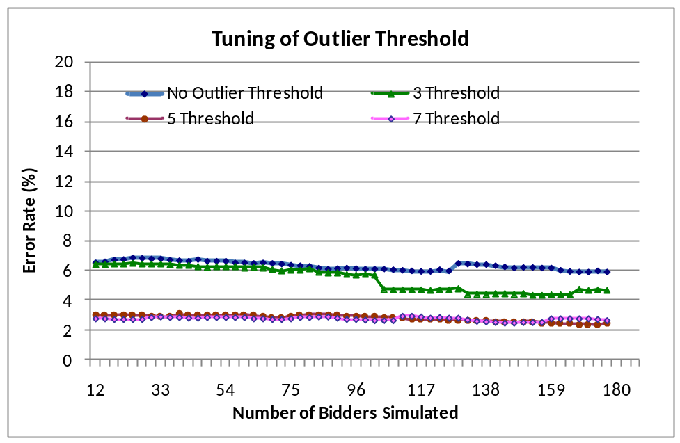
Figure 7.28 Experimental Results for Tuning of Outlier Threshold
Not displayed in the results is a threshold value of 1, which removes useful diversity from the data and results in excessively poor performance. Marking no bidders as outliers is also bad for the performance of the network. This is due to the small window size that we utilize throughout the experiment. Any outliers in a small training or validation set will heavily skew the distribution of that set and bring confusion to the network training. A larger window size, however, will lead to increased training times and potential overfitting. As a result, we choose to remove outliers and keep the small window size.

[25] discusses that many statistical works utilize an optimal threshold of 3 for their purposes, but this threshold will vary depending on the dataset. For our dataset, a threshold of 3 removes too many bidders from the dataset, leading to data that looks too similar. A threshold of 5 or 7 appears to be optimal for our approach. We decide to choose a threshold of 5 due to the harmful effects outliers can have on our small window sizes; a threshold of 7 is more likely to allow a harmful outlier to exist in the dataset and is thus more risky to use.

Hidden Neurons

The number of hidden neurons used in the neural network, as discussed previously, is the primary parameter to tune when utilizing resilient backpropagation. For this experiment, we ran the simulation with 1, 3, 5, and 7 hidden neurons. We display the results of these experiment runs in Figure 7.29.

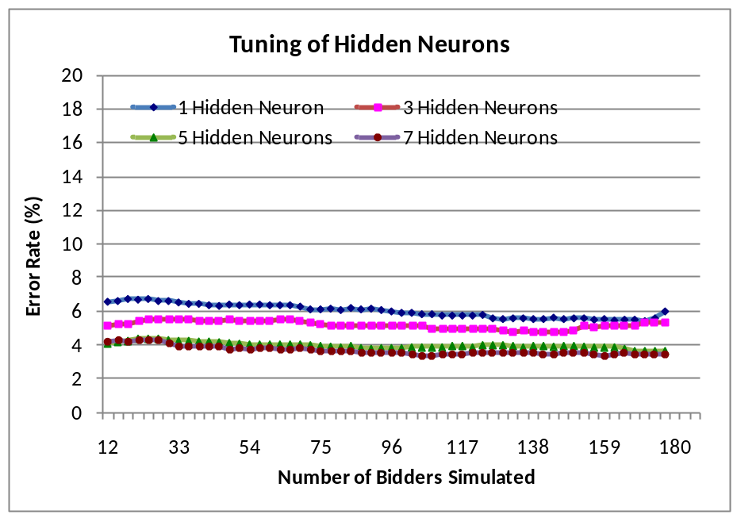
Figure 7.29 Experimental Results for Tuning of Hidden Neurons
Although not as dramatic as the other experiments, this experiment does demonstrate the importance of choosing the correct number of hidden neurons for the problem. The 1 and 3 hidden neuron cases demonstrate how an insufficient number of hidden neurons can weaken the network’s ability to converge on an optimal solution. All other hidden neuron counts exhibit an acceptable error rate curve for this experiment. In addition to accuracy considerations, it is also best for a real-time approach to choose a lower number of hidden neurons. Because every training epoch involves calculating values for every weight and bias in the network, more hidden neurons will lead to significantly more weight and bias updates for each epoch. For example, a network with 18 input neurons, 5 hidden neurons, and 2 output neurons contains 180 weights and 7 biases. A network with the same number of input and output neurons, but 10 hidden neurons, contains 360 weights and 12 biases. As a result, we choose 5 hidden neurons as the optimal value.

7.3.3 Experiments to Demonstrate Classifier Adaptation

Experiment 1

This simulation’s goal is to demonstrate how the classifier performs when initially trained on data that is only days older than the new auction data being presented to it. The simulation process utilizes dataset 1 exclusively and is described in full detail in section 7.3.1. The accuracy results are displayed in Figure 7.30.

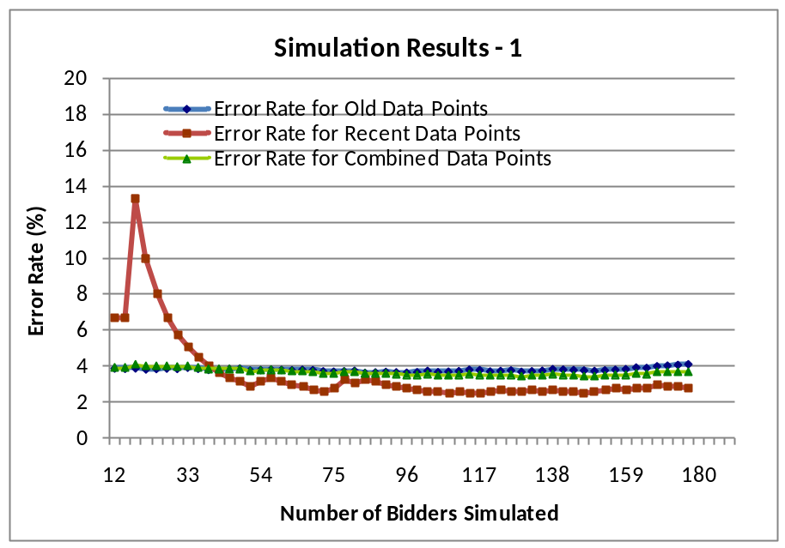
Figure 7.30 Simulation Results for Recent Data Points Collected without a Time Gap

It is important to note the importance of a large enough test set in both of the following experiment results. For this experiment, the error rate for the simulation dataset is artificially high when the test set size is low. Note that the combined error rate, as defined in Figure 7.26, does not fluctuate significantly, even when the error rate for the simulation dataset drops. This is because there are few misclassifications in the simulation dataset throughout the simulation, even though the small test set causes a single misclassification to display a high error rate.

By examining the error rates for both datasets and the combined error rate, it would appear that the network did not learn anything new from the simulation dataset. This is not surprising, since the simulation dataset is comprised of similar auctions in the same month as the initialization dataset; these two datasets should contain similar, if not nearly identical, behavior. These results also demonstrate that the network will attempt to learn new data in a stable and controlled manner; the error rates for both datasets fluctuated only slightly throughout the majority of the process.

Figure 7.31 displays the time performance results of the entire simulation process, including classification of the new auction’s bidders, SR module processing, and classifier adaptation to the new bidders. The relatively stable time performance demonstrates that the neural network can quickly classify and adapt to new bidding data. The few spikes in time performance may correspond to auctions with a large number of participating bidders. It is also possible that the classifier had a particularly difficult training run, resulting in more iterations being performed in the training process. When compared with the accuracy results, it is apparent that a difficult training run is unlikely, since the classifier performance does not fluctuate significantly at any point. Regardless of these fluctuations, the time performance is fast enough to be used in a real-time environment.

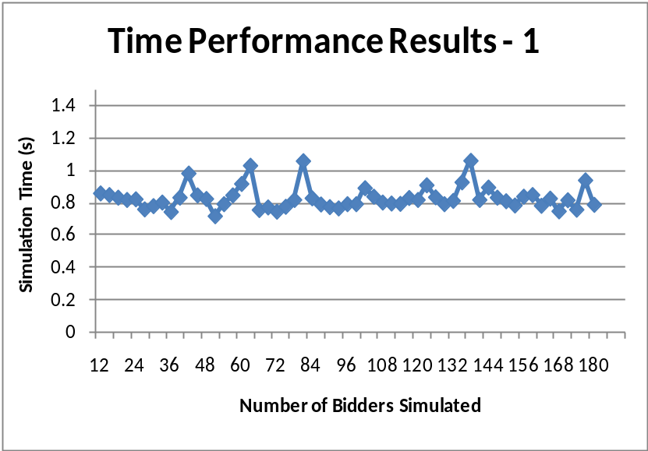
Figure 7.31 Time results for recent data points collected without a time gap

Experiment 2

This simulation is designed to demonstrate how the classifier performs when adapting to data that is significantly newer than the initialization dataset. First, the network is initialized similarly to the process described in section 7.3.1, except the initialization dataset contains all 153 auctions of the dataset 1. Next, the classifier uses dataset 2 as the simulation set and processes it similarly to section 7.3.1, with a few exceptions. Since there is a gap of approximately six months between the two datasets, we inform the classifier to not classify any received auction data. The potential differences between the two datasets may be too significant for the neural network to properly classify the new data. Instead, the classifier will send all received points to the verifier and apply the returned classification to the bidders. This subroutine will continue until 9 bidders, enough to fill a training window, have been processed by the classifier. At this point, the classifier will send the current auction’s bidders to the verifier, noting the returned classifications. The classifier will then resume the process described in section 7.3.1, as it now has enough data to properly adapt the network to the simulation dataset. Since its last training cycle provided the classifier with sufficient information to classify new data, the classifier will also resume its classification role. Figure 7.32 displays the results for this experiment.

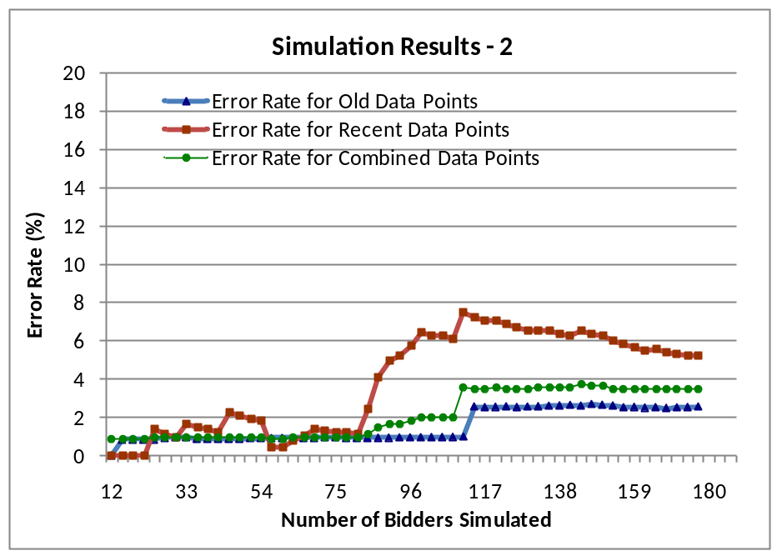
Figure 7.32 Simulation Results for Recent Data Points Collected with a Time Gap

For this experiment, however, there is a significant increase in error for the simulation dataset around 90 processed bidders. Once the classifier has processed enough of the simulation dataset, approximately 90 bidders, the created test sets will accurately depict the classifier’s accuracy on the simulation dataset. This phenomenon does not occur with the initialization dataset because the created test set is originally of size 500 – more than enough to be representative. Note that when the error increases for the simulation dataset, the error does not increase for the initialization dataset due to dataset 1 being accurately represented.

Comparing these results to the previous results for dataset 1, there are some obvious differences and few similarities. The initially low and stable error rate for dataset 1 is the only noticeable similarity. When the test set size is approximately 90 bidders, the simulation dataset error starts at a much higher, but still acceptable, rate. It is interesting to note that this error rate gradually improves throughout the rest of the simulation process, finally ending at about 5% error. In contrast, dataset 1’s error rate increases gradually throughout the simulation.

The composition of the two datasets explains the trends of both error rates in this simulation. Although the simulation dataset was collected approximately 6 months after dataset 1, bidder behavior should not have changed too drastically to consider the two datasets as distinctly different. However, the differences in the two datasets, discussed in section 7.1, are sufficient enough to consider them as slightly different. In addition, the cluster labeling differences are further proof that the two datasets are largely similar but slightly different. Most of the observed suspicious behavior is similar in both datasets, with a few exceptions. One example, in the simulation dataset, is the lack of a highly suspicious group of bidders that places a very large number of bids in the early stage of the auction.

Although Figure 7.32 displays slight error rate fluctuations, Figure 7.33 displays predictable time performance of the simulation process. Similar to Figure 7.31, these results demonstrate that our process can be effectively utilized in a real-time environment.

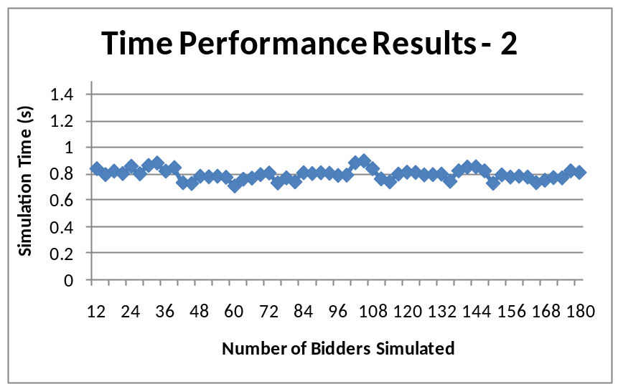
Figure 7.33 Time results for recent data points collected with a time gap

Conclusions and Future Work

The increasing popularity of online auctions is almost sure to lead to an increase in auction fraud activities, either obvious or covert. Detecting covert shill bidding in this rapidly growing space requires the use of advanced automated techniques that can adapt to changes in bidding trends. In this paper, we introduced a series of attributes that effectively describe important aspects of bidder behavior and other useful information about the auctions in which the bidders participate. These attributes allow us to take advantage of automated data mining techniques. We then presented the real-time self-adaptive classifier, which is capable of accurate classification and smooth adaptation to new data. In addition, it performs fast enough to be utilized in a real-time environment. By utilizing external Prolog rule modules and a separate classification module, the classifier is easily extensible with little to no rewriting of the implementation code. When used in conjunction with existing shill verification techniques, our classifier can greatly increase their efficiency.

For future work, we will investigate the use of Support Vector Machines (SVMs) as an alternative to neural networks. SVMs have seen successful application in other fields, such as network intrusion detection [32, 33]. [33] notes that SVMs are slightly more accurate and much faster than traditional neural networks, but SVMs also have a set of unique issues that need to be addressed, such as the proper choice of a kernel function. Surprisingly, SVMs have not yet been applied to shill bidding behavior detection.

References
- PSU, “Auction Site Count, Keep Track of the Number of Listings on Auction Sites,” Power Sellers Unite (PSU), Retrieved on July 20, 2010, from http://www.powersellersunite.com/auctionsitewatch.php
- F. Dong, S. M. Shatz, and H. Xu, “Combating Online In-Auction Fraud: Clues, Techniques and Challenges,” Computer Science Review (CSR), Vol. 3, No. 4, November 2009, pp. 245-258.
- D. H. Chau, S. Pandit, and C. Faloutsos, “Detecting Fraudulent Personalities in Networks of Online Auctioneers,” In Proceedings of 10th European Conference on Principles and Practice of Knowledge Discovery in Databases (PKDD 2006), Berlin, Germany, September 18-22, 2006, pp. 103-114.
- G. Swamynathan, B. Y. Zhao, K. C. Almeroth, and S. R. Jammalamadaka, “Towards Reliable Reputations for Dynamic Networked Systems,” In Proceedings IEEE Symposium on Reliable Distributed Systems (SRDS’08), 2008, Oct. 2008, pp.195–204.
- F. Dong, S. M. Shatz, and H. Xu, “Reasoning Under Uncertainty for Shill Detection in Online Auctions Using Dempster-Shafer Theory,” To appear in International Journal of Software Engineering and Knowledge Engineering (IJSEKE), 2010.
- R. Bapna, P. Goes and A. Gupta, “User Heterogeneity and its Impact on Electronic Auction Market Design: An Empirical Exploration,” In MIS Quarterly, Vol. 28, no. 1, 2004.
- H. S. Shah, N. R. Joshi, A. Sureka, and P. R. Wurman, “Mining for Bidding Strategies on eBay,” In Lecture Notes in Artificial Intelligence, Springer-Verlag, 2003.
- J. Hou and C. Rego, “A Classification of Online Bidders in a Private Value Auction: Evidence from eBay,” International Journal of Electronic Marketing and Retailing, Vol. 1, no. 4, 2007, pp. 322-338.
- H. Xu, C. K. Bates, and S. M. Shatz, “Real-Time Model Checking for Shill Detection in Live Online Auctions,” In Proceedings of the International Conference on Software Engineering Research and Practice (SERP'09), July 13-16, 2009, Las Vegas, Nevada, USA, pp. 134-140.
- A. Goel, H. Xu, and S. Shatz, "A Multi-State Bayesian Network for Shill Verification in Online Auctions," In Proceedings of the 22nd International Conference on Software Engineering and Knowledge Engineering (SEKE'2010), Redwood City, San Francisco Bay, USA, July 2010, pp. 279-285.
- F. Dong, S. M. Shatz, and H. Xu, "An Empirical Evaluation on the Relationship Between Final Auction Price and Shilling Activity in Online Auctions," In Proceedings of the 22nd International Conference on Software Engineering and Knowledge Engineering (SEKE'2010), Redwood City, San Francisco Bay, USA, July 2010, pp. 286-291.
- J.C. Wang and C.Q. Chiu, "Detecting online auction inflated-reputation behaviors using Social Network Analysis," In North American Association for Computational Social and Organizational Science (NAACSOS 2005), Notre Dame, Indiana, USA, 2005.
- H. B. Yin, S. C. Wong, J. M. Xu, and C. K. Wong, “Urban trafﬁc ﬂow prediction using a fuzzy-neural approach,” In Transportation Research Part C: Emerging Technologies, Apr 2002, vol. 10, no. 2, pp. 85–98.
- Y.Yang, D. M. Vilathgamuwa, and M. A. Rahman, “Implementation of an artiﬁcial-neural-network-based real-time adaptive controller for an interior permanent-magnet motor drive,” In IEEE Transactions on Industry Applications, Jan/Feb 2003, vol. 39, no. 1, pp. 96–104.
- C. D. Manning, P. Raghavan, and H. Schütze, Introduction to Information Retrieval, Cambridge University Press, 2008.
- Jiang Su and Harry Zhang, “A Fast Decision Tree Learning Algorithm," In Proceedings of the 21st National Conference on Artificial Intelligence, July 16-20, 2006, Boston, Massachusetts, USA, pp. 500-505.
- H. Abdi, "A Neural Network Primer," In Journal of Biological Systems, Vol. 2, 1994, pp. 247-281.
- M. Riedmiller and H. Braun, " A Direct Adaptive Method for Faster Backpropagation Learning: The RPROP Algorithm," In Proceedings of the IEEE International Conference on Neural Networks (ICNN), Piscataway, NJ, USA, Vol. 16, pp. 586-591.
- G. Zhou and J. Si, "Subset-based training and pruning of sigmoid neural networks," In Neural Networks, Vol. 12, pp. 79-89.
- C. Brooks, "Artificial Intelligence Programming: More Neural Networks," Presentation Slides, Department of Computer Science, University of San Francisco, San Francisco, CA, USA.
- A. Saxena and A. Saad, "Evolving an Artificial Neural Network Classifier for Condition Monitoring of Rotating Mechanical Systems," In Applied Soft Computing, Vol. 7, 2007, pp. 441–454.
- J. Engelberg, J. Williams, “EBay’s Proxy Bidding: A License to Shill,” Journal of Economic Behavior & Organization, Vol. 72, no. 1, October 2009, pp. 509-526.
- D. Houser and J. Wooders, “Reputation in Auctions: Theory and Evidence from eBay,” Journal of Economics and Management Strategy, Vol. 15, no. 2, 2006, pp.353-369.
- J. A. Livingston, “How Valuable is a Good Reputation? A Sample Selection Model of Internet Auctions,” The Review of Economics and Statistics, Vol. 87, No. 3, 2005, pp.453-465.
- J.W. Osborne and A. Overbay. “The power of outliers (and why researchers should always check for them),” In Practical Assessment, Research & Evaluation, Vol. 9, no. 6, Retrieved July 25, 2010 from http://PAREonline.net/getvn.asp?v=9&n=6.
- R. Balingit, J. Trevathan, and W. Read, “Analyzing Bidding Trends in Online Auctions,” In Proceedings of the 6th International Conference on Information Technology: New Generations (ITNG), 2009, pp.928-933.
- HCIL, Hierarchical Clustering Explorer for Interactive Exploration of Multidimensional Data, Human Computer Interaction Lab, Retrieved on September 18, 2009, from: http://www.cs.umd.edu/hcil/hce
- J.V. Tu, “Advantages and Disadvantages of Using Artificial Neural Networks versus Logistic Regression for Predicting Medical Outcomes,” In J Clin Epidemiol, Vol. 49, no. 11, 1996, pp. 1225-1231.
- Jeff Heaton, Encog Java and DotNet Neural Network Framework, Heaton Research, Inc., Retrieved on July 20, 2010, from: http://www.heatonresearch.com/encog
- M. Littman, "Chapter 3: Decision Tree Learning," Presentation Slides, Department of Computer Science, Rutgers University, NJ, USA.
- S. Lawrence, C.L. Giles, A. C. Tsoi, “Lessons in Neural Network Training: Overﬁtting May be Harder than Expected,” In Proceedings of the Fourteenth National Conference on Artificial Intelligence, 1997, Providence, RI, pp. 540-545.
- S. Mukkamala, G. Janoski, A. Sung, "Intrusion Detection: Support Vector Machines and Neural Networks," In Proceedings of the IEEE International Joint Conference on Neural Networks (ANNIE), 2002, St. Louis, MO, pp. 1702–1707.
- R. Akbani, T. Korkmaz and G.V.S. Raju, "Defending Against Malicious Nodes Using an SVM Based Reputation System," In Proceedings of MILCOM, Nov 16-19, 2008, San Diego, CA, pp. 1-7.

